CHAPTER 1
1.1 INTRODUCTION TO MECHANISM:
A mechanism is a device designed to transform input forces and movement into a desired set of output forces and movement. Mechanism generally consists of moving components such as gears and gear trains, belt and chain drives, cam and follower mechanisms, and linkages as well as friction devices such as brakes and clutches, and structural components such as the frame, fasteners, bearings, springs, lubricants, and seals, as well as a variety of specialized machine elements such as splines, pins and keys.
The German scientist Reuleaux provides the definition “a machine is a combination of resistant bodies so arranged that by their means the mechanical forces of nature can be compelled to do work accompanied by certain determinate motion”. In this context, his use of machine is generally interpreted to mean mechanism.
The combination of force and movement defines power, and a mechanism is designed to manage power in order to achieve a desired set of forces and movement.
A mechanism is usually a piece of a larger process or mechanical system. Sometimes as entire machine may be referred to as a mechanism.
Examples: The steering mechanism in a car, or the winding mechanism of a wristwatch.
1.2 TYPES OF MECHANISM:
From the times of Archimedes through the Renaissance, the mechanisms were considered to be constructed from simple machines, such as the lever, pulley, screw, wheel and axle, wedge and inclined plane. It was Reuleaux who focussed on bodies, called links, and the connections between these bodies called kinematic pairs, or joints.
In order to use geometry to study the movements of a mechanism, its links are modelled as rigid bodies. This means distances between points in a link are assumed to be unchanged as the mechanism moves, that is the link does not flex. Thus, the relative movement between points in two connected links is considered to result from the kinematic pair that joins them.
Kinematic pairs, or joints, are considered to provide ideal constrains between two links, such as the constraints of a single point for pure rotation, or the constraint of a line for pure sliding, as well as pure rolling without slipping and point contact with slipping. A mechanism is modelled as an assembly of rigid links and kinematic pairs.
1.3 KINEMATIC PAIRS:
Reuleaux called the ideal connections between links kinematic pairs. He distinguished between higher pairs which were said to have line contact between the two links and lower pairs that have area contact between the links. J.Phillips shows that there are many ways to construct pairs that do not fit this simple.
1.3.1 Lower Pair: A lower pair is an ideal joint that has surface contact between the pair of elements. We have the following cases:
- A revolute pair, or hinged joint, requires a line in the moving body to remain co-linear with a line in the fixed body, and a plane perpendicular to this line in moving body maintain contact with a similar perpendicular plane in the fixe body. This imposes five constrains on the relative movement of the links, which therefore has one degree of freedom
- A prismatic joint, or slider, requires that a line in the moving body remain co-linear with a line in the fixed body, and a plane parallel to this line in the moving body maintain contact with a similar parallel plane in the fixed body. This imposes five constraints on the relative movement of the links, which therefore has one degree of freedom.
- A cylindrical joint requires that a line in the moving body remain co-linear with a line in the fixed body. It is a combination of a revolute joint and a sliding joint. This joint has two degree of freedom.
- A spherical joint, or ball joint, requires that a point in the moving body maintain contact with a point in the fixed body. This joint has three degrees of freedom.
- A planar joint requires that a plane in the moving body maintain contact with a plane in fixed body. This joint has three degree of freedom.
- A screw joint, or helical joint, has only one degree of freedom because the sliding and rotational motions are related by the helix angle of the thread.
1.3.2 Higher Pair: Generally, a higher pair is a constraint that requires a line or point of contact between the element surfaces.
For example, the contact between a cam and its follower is a higher pair called a cam joint. Similarly, the contact between the involute curves that from the meshing teeth of two gears are cam joints.
1.4 Planar Mechanism:
A planar mechanism is a mechanical system that is constrained so the trajectories of points in all the bodies of a system lie on planes parallel to a ground plane. The rotational axes of hinged joints that connect the bodies in the system are perpendicular to this ground plane.
1.5 Spherical Mechanism:
A spherical mechanism is a mechanical system in which the bodies move in a way that the trajectories of point in the system lie on concentric spheres. The rotational axes of hinged joints that connect the bodies in the system pass through the center of these spheres.

1.6 Spatial Mechanism:
A spatial mechanism is a mechanical system that has at least one body that moves in a way that its point trajectories are general space curves. The rotational axes of hinged joints that connect the bodies in the system from lines in space that do not intersect and have distinct common normal.
1.7 Cam and Follower Mechanism:
A cam and follower is formed by the direct contact of two specially shaped links. The driving link is called the cam(also see cam shaft) and the link that is driven through the direct contact of their surfaces is called the follower. The shape of the contacting surfaces of the cam and follower determines the movement of the mechanism. In general a cam follower mechanism’s energy is transferred from cam to follower. The cam shaft is rotated and, according to the cam profile, the follower moves up and down. Now slightly different types of eccentric cam followers are also available in which energy is transferred from the follower to the cam. The main benefit of this type of cam follower mechanism is that the follower moves a little bit and helps to rotate the cam 6 times more circumference length with 70% force.
1.8 Flexure Mechanism:
A flexure mechanism consisted of a series of rigid bodies connected by compliant elements (flexure bearing also known as flexure joint) that is designed to produce a geometrically well-defined motion upon application of a force.

CHAPTER 2
LITERATURE REVIEW:
Before commencing any design work it is useful to see what is already being done by others in the same field. As mentioned in the introduction Geneva mechanism , is also called Geneva stop, one of the most commonly used device for producing intermittent rotary motion, characterizes by alternative periods of motion and rest with no reversal in direction. It is also used in indexing.

For a background for the elimination of the shock loading at beginning and end of the motion a research paper was reviewed. The paper “DEVELOPMENT OF A NEW GENEVA MECHANISM WITH IMPROVED KINEMATIC CHARACTERISTICS” by R.G.Fenton, Y.Zhang and J.Xu. The paper discus about the reduction of the peak acceleration values and peak velocity values, and making the new mechanism well suited for high speed application. And furthermore it discuss about improvement to the designed of a curve slotted Geneva wheel, by introducing an offset to the curved slot. Another research paper “TWO STATION GENEVA MECHANISMS” Y.Zhang, R.G.Fenton and J.Xu provided information about two different methods for reducing the size of the slot and change its shape in order to make the mechanism feasible foe practical application. The reduction of the slot size is achieved either by choosing appropriate value for α. Which are highly related to this project because with this information we reduce the usage of work and time.

Another text was found from the books “CLASSIFICATION AND MODERN MECHANISMS FOR ENGINEERS AND INVENTORS” by Jensen and “THEORY OF MACHINES AND MECHANISM” by E.Bautista give the information about the description and motion characteristics. The motion characteristics give the rotation of the Geneva wheel which is the major part for the production of feed.

Another text that was found from the book “GENEVA MECHANISM” by Bin Zhang provides a major information about the lengths and dimensions to the Geneva wheel which is used for the construction of the Geneva wheel.

CHAPTER 3
3.1 INTRODUCTION TO GENEVA MECHANISM:
The Geneva is one of the earliest of all intermittent motion mechanism and when input is in the form of continuous rotation, it is probably still the most commonly used, Geneva’s are available on an off the self-basis from several manufacturers, in a variety of sizes. They are cheaper than cams or star wheels and have adequate to good performance characteristics, depending on load factor and other design requirements.
3.2 Advantages of Geneva Mechanism:
Genevas may be the simplest and least expensive of all intermittent mechanisms, as mentioned before, they come in wide variety of sizes, ranging from those used in instruments, to those used in machine tools to index spindle carriers weighing several tons. They have good motion-curve characteristics compared to ratchets, but exhibit more “jerk”, or instantaneous change in acceleration, than do better cam systems
The Geneva maintains good control of its load at all times, since it is provided with locking ring surface, as shown in fig, to hold the output during dwell periods. In addition, if properly sized to the load, the Geneva generally exhibits very long life. One machine tool manufacturer told that their Geneva will last 20 years, indexing once every few seconds, on a three-shaft basis, driving a spindle carrier weighing one ton. This particular Geneva was about 18 inches diameter.
3.3 Disadvantages of Geneva mechanism:
The Geneva is not a versatile mechanism. It can be used to produce no less than three, and usually no more than 18 dwells per revolution of the output shaft. Furthermore, once the number of dwells has been selected, the designer is well locked into a given set of motion curves. The ration of dwell period to motion period is also established once the number of dwells per revolution has been selected. Also, all Geneva acceleration curves start and end with finite acceleration and deceleration. This means they produce jerk.
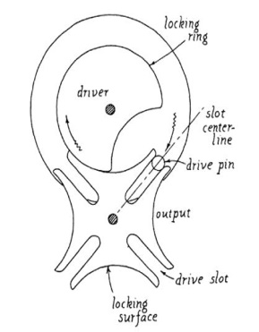

Fig 3.3 Geneva Mechanism
3.4 Types of Genevas:
There are three types of Genevas:
- External, which is the most popular
- Internal, which is also very common
- Spherical, which is extremely rare.
3.4.1 External Geneva mechanism:
Geneva mechanism is used as a mechanism for transforming rotary motion into intermittent motion running with acceleration jumps at the beginning and the end of the active phases. The mechanism provides a precise positioning movement and its blockage, which makes it usable in many areas.
Synthesis of mechanism aims to determine the size and number of channels constructive established by different coefficients and in function of acting time
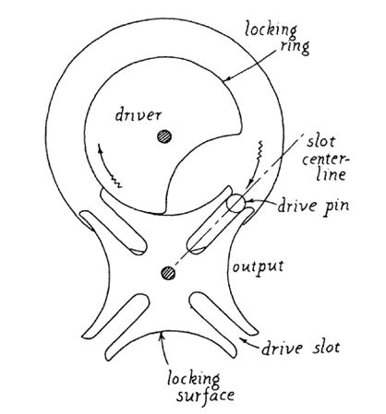
Fig 3.4.1 External Geneva Mechanism
3.4.2 Internal Geneva mechanism:
An internal Geneva drive is a variant on the design. The axis of the drive wheel of the internal drive can have a bearing only on one side.
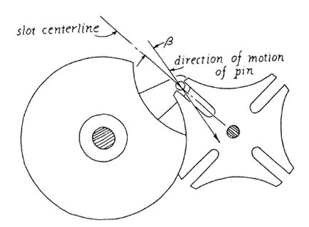

The angle by which the drive wheel has to rotate to effect one step rotation of the driven wheel is always smaller than 180° in an external Geneva drive and always greater than 180° in an internal one, where the switch time is therefore greater than the time the driven wheel stands still.
3.4.3 Spherical Geneva mechanism:
Genevas are also combined with a wide variety of other mechanisms, such as four bar linkages, clutch brake combination, noncircular gears, etc., to modify the motion curves and dwell motion ratios obtained from a pure Geneva.
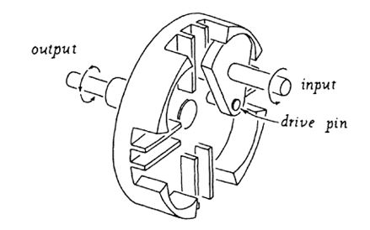
Fig 3.4.3 Spherical Geneva Mechanism
3.5 Miscellaneous comments:
In a well-designed Geneva the drive pin will enter the slots of the output wheel along an arc that is tangent to the centerline of the slot, as shown in fig. If the direction of motion of the pin deviates from the slot centerline by an angle β, shown in fig, compact can result. This will either be a positive or negative impact (that is, it will produce either a positive or a negative torque on the driver) depending upon whether the slot is at some angle above the target line of the pins motion or at some angle below it. Fig shows a situation whether the tangent line is below the pins motion line. The fig shows the displacement curves that result from three situations: the deviation (angle β) is ±5 degrees or 0 degrees (tangent). There does not seem to be much different between these three curves, each of which represent only the first few degrees of motion of the output member rather than the complete displacement curve. The velocity curves for these three situations, also shown in fig, do not appear to have change much either.
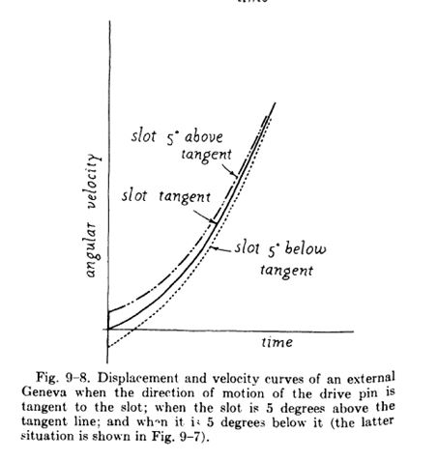

If we now plot the acceleration curves, however we will find that we have introduced impact when the slots centerline was above or below the line tangent to the pins motion. This is because the angular velocity in each case starts at a finite positive or negative value: and instantaneous change in velocity means an infinite acceleration which, in turn wheel. Elasticity in the system may allow the pin to chatter from one side of the slot to the other as it drives the wheel, producing a series of impact which can cause all sorts of trouble.
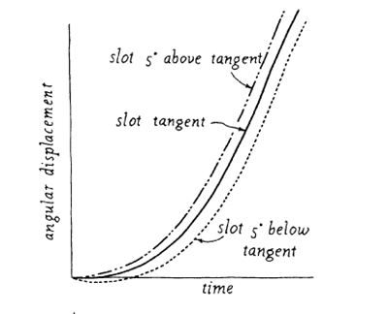

3.6 BACKGROUND AND DESIGN PROCEDURE:
The name derives from the devices earliest application in mechanical matches, Geneva, Switzerland being an important center of watchmaking. The Geneva drive is also commonly called a Maltese cross mechanism due to the visual resemblance when the driven wheel has four spokes. Since they can be made small and are able to withstand substantial mechanical stress, these mechanism are frequently used in watches
In the most common arrangement, the driven wheel has four slots and thus advances by one step of 90 degrees for each rotation of the drive wheel. If the driven wheel has n slots, it advances by 360°/n per full rotation of the drive wheel.
One task of a mechanical designer is to synthesize a mechanism that achieves a particular task. Synthesis procedures are usually classified as either function generation, path generation, or motion generation. Cams, gears, and linkages can be combined where a point on one of the links traces a general planar curve. Planar path generation can be central to the kinematic design of a Geneva wheel mechanism.
A 4-bar mechanism is a basic 1-dof (degree of freedom) mechanism. A 4-bar is created by selecting four link length and joining the links with revolute joints to form a loop. A wide variety of paths are possible by arbitrary choosing a point on the coupler curve. These different curves can be obtained by constructing a physical model of the mechanism and viewing the path of various points without detailed mathematical analysis. It is also possible to develop a mathematical model of the mechanism in terms of its four link lengths. The analytical expressions for these paths are algebraic and require many computations to determine the coordinate for points on the path. Handbooks were developed to catalogue many curve forms, their instantaneous properties, and the corresponding mechanism used to produce them. Burmester developed a procedure to determine the link lengths of a 4-bar mechanism that will guide its coupler curve in a prescribed manner. The mathematical formulation of this procedure for designing a 4-bar mechanism is referred to as Burmester theory. Freudenstein introduced the use of a computer for the design of 4-bar mechanisms. This activity precipitated much interest in creating additional analytical approaches to specify mechanisms capable of satisfying a desired task. Much of the work fostered by Freudenstein is highlighted by Erdman. The methodology developed by Freudenstein and Sandor for path generation consists of specifying a finite number of points (precision points) on the desired curve and results in a 4-bar mechanism where a point on the coupler curve passes through the specified precision points. Interestingly, the number of points is usually three, four or five. This methodology of path generation is referred to as an exact method.
One problem with designing a 4-bar mechanism for path generation is that the final 4-bar mechanism is rarely able to produce the desired path. For this reason, optimal synthesis methods were used to design mechanisms for path generation. The objective is to minimize the structural error defined as the difference between a prescribed path and the generated path. An optimal mechanism is synthesized by summing the difference between these paths over the full operative domain and changing the mechanism parameters to reduce this net difference. One disadvantage of the exact method is that only a few precision points can be used whereas one disadvantage of optimal methods is that an approximation to the desired task exists. These disadvantages can be eliminated by integrating higher order pairs (viz., cams, gears, and pin-in-slots) with linkages. In 1967, Hain cited the existence of cam-linkage mechanisms, while in 1981 Singh and Kohli used the complex loop closure method and the envelope theory to define a general approach for the synthesis of combined cam-linkage systems for exact path generation. In 2006, Mundo et al. Proposed a method for the optimal synthesis of planar mechanisms where a combination of cams and linkages are used to obtain precise path generation.
Task performing mechanisms can also be obtained by integrating linkages with geared-bodies. Roth and Freudenstein proposed a numerical method for the synthesis of a geared five-bar mechanism (GFBM) for path generation tasks defined by nine precision points. Zhang et al. proposed an algorithm for the optimal synthesis of a symmetric GFBM as a path generating mechanism. Starns and Flugrad used continuation methods to synthesize a GFBM for a path generation task defined by seven precision positions. Nokleby and Podhorodesky proposed a method for the optimal synthesis of GFBM based on a quasi-Newton optimization routine.
Recently, a combination of linkages with non-circular gears was proposed for different purposes, such as balancing shaking moments in spatial linkages, reducing speed and torque fluctuations in rotating shafts, reducing the driving torque fluctuations in GFBMs, synthesizing path-generating mechanisms with time-prescription. Mundo et al. Proposed the integration of five-bar linkages with non-circular gears to synthesize a mechanism capable of precisely moving a coupler point along a desired path, while a non-circular gear pair is designed in to drive a ball-screw mechanism according to an optimal law of motion. Presented are different gear trains incorporating circular and non-circular gears as driving mechanisms for a classical Geneva wheel. The goal is to achieve intermittent motion with improved kinematic behaviour.
3.7 Geneva wheel
Intermittent drives are used in industry for counting mechanisms, indexing, sequencing, motion-picture mechanisms, feed mechanisms, and watches, although less common today with programmable controllers. A Geneva wheel is an example of an intermittent motion mechanism. Typically, the Geneva wheel is driven by a pin that traverses a circular path; this is the classical Geneva wheel mechanism. The path of the pin will vary later. One undesirable feature of the classical Geneva wheel mechanism is that an acceleration jump exists at the start and stop of the Geneva wheel motion. Several mechanisms have been proposed to reduce and eliminate this acceleration jump. Hunt proposed a 4-link crank-rocker to generate a coupler curve to eliminate these acceleration jumps. Dijksman presented more complex mechanisms to eliminate the acceleration jump at the onset of Geneva wheel motion. Later, Sujan and Meggiolaro used a 4-bar mechanism for improving Geneva wheel dynamics. None of the proposed mechanisms are as compact as the classical Geneva wheel drive. Further, balancing these mechanisms becomes a challenge where Geneva wheels driven by linkages are not common.
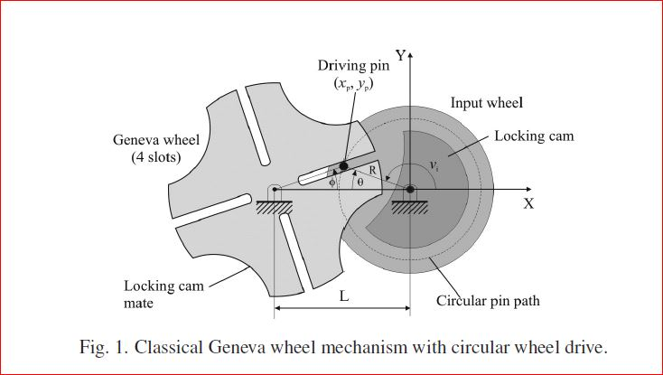
Fenton et al proposed curved slots along with a slot offset to improve the motion characteristics of the Geneva wheel. Figliolini and Angeles presented an algorithm on the synthesis of Geneva wheel drives with curved slots using a specified motion. More recently, Lee and Jan expanded this concept with focus on undercutting. Quaglia et al. Introduced counter rotating geared wheels that engage and disengage with an output wheel to generate an oscillating motion in the output wheel. The output wheel is held stationary using slots akin to the Geneva wheel. Acceleration spikes at engagement and disengagement are eliminated by using specially shaped slots. Figliolini et al eliminated the sliding motion inherent between the pin and slot using cams. Hasty and Potts consider wear and maximum contact stress for a classical drive Geneva wheel mechanism. These same considerations can be extended today using updated design formulations for wear and stress along with optimizations procedures. Recent applications incorporating a Geneva wheel mechanism include the design of a shoulder joint and an insect like flapping wing mechanism.

A classical 4-slotted Geneva wheel mechanism is illustrated in Fig. 1. Typically, mechanical designers will incorporate a circular wheel with a pin as shown in Fig. 1. The rotation of the Geneva wheel is prevented when the pin is not in the slot using the locking cam illustrated in Fig. 1. Referencing Fig. 1, the following relation is obtained via the law of sines:
$R/(SIN∅)=L/SIN[π-(∅+θ) ]$
Where for n slots
$-π/n<∅<π/n$

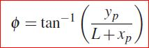
Note that the angle $∅$ spans the open interval (−π /n, π /n). Solving for the angular position $∅$ of the Geneva wheel in terms of the Cartesian coordinates (xp, yp) of the pin yields.

Expressing the angle $θ$ in terms of coordinates (xp,yp) gives
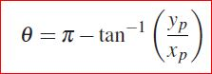

3.8 PATH GENERATION:
The motion of the classical Geneva wheel mechanism is based on the circular path of the driving pin. The Cartesian coordinates (xp, yp) of the pin are expressed
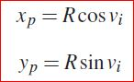

Where R is the radius of the pin and vi is the angular position of the input wheel. The Geneva wheel motion can be altered by utilizing a path other than a circular pin path. An alternative path can be produced using a gear pair where the input gear is held stationary and the connecting link is allowed to rotate. Illustrated in Fig. 2 are two non-circular gears where the “input” non-circular gear (centrode) is held stationary and the output non-circular gear (centrode) is moving. The point p in the output gear traces a planar path. The output centrode rotates without slip along the input centrode. Depicted in Fig. 3 is a special case where the gears are circular. The motion of the point q embedded in the moving output gear describes an epitrochoid. One special case is when the distance rd is equal to the gear radius where the resulting path is an epicycloid. When the input gear and the output gear are of equal diameters, there exists one cusp and the epicycloid is defined as a cardioid. When two cusps exist (i.e., diameter of the fixed gear is twice the diameter of the moving gear), the epicycloid is defined as a nephroid.
The goal is to determine a suitable pin path for driving the Geneva wheel and subsequently determine the corresponding non-circular gear pair. A suitable pin path is one that yields smooth and continuous velocity.
Fig. 2. A point p traces a planar path (xp , yp ) using non-circular output gear (moving NC output gear) rotating without slip relative to the fixed input gear and acceleration of the Geneva wheel.

The driving pin path determines the non-circular gear shapes and the non-circular gear shapes define the pin path. Thus, the relation between the instantaneous gear ratio and the pin path is presented. Subsequently, zero acceleration of the Geneva wheel is defined in terms of the driving pin path and its derivatives.
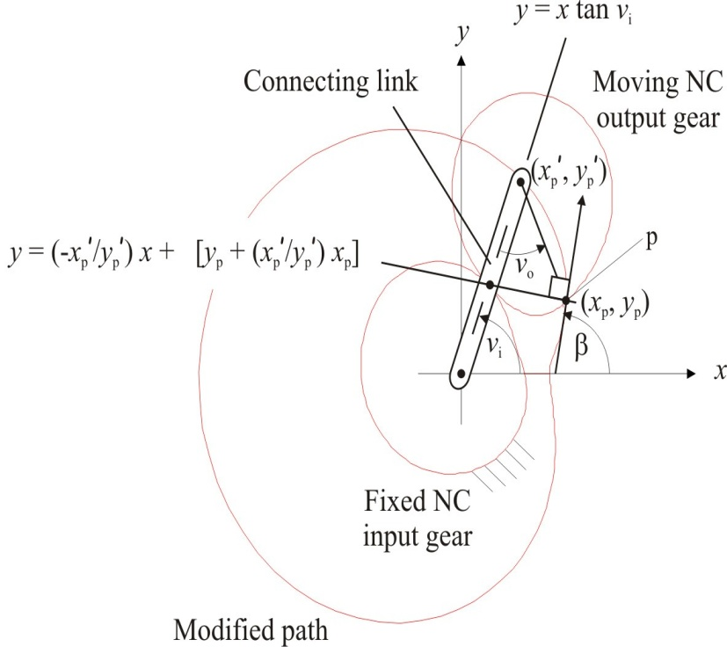

Fig.3.8.1
The Cartesian coordinates (xp, yp) for a general planar path are
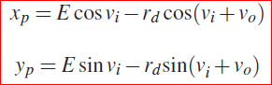

Where E is the connecting link center distance between the two gears, rd is the distance of the driving pin p from the center of the moving gear, vi is the angular position of the connecting link and vo is the corresponding angular position of the output gear. The path tangency is defined using the angle β (see Fig 2) where
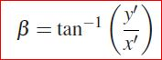
Using a Geneva wheel with n slots, tan (π /n) = tan β at initial engagement. For example, β = 240◦ for n = 3, β = 225◦ for n = 4, and β = 210◦ for n = 6. The angle vi that satisfies this relation provides an initial value to determine the instantaneous gear ratio g and the derivative g0 (g0 ≡ dg/dvi). Zero acceleration is ensured when
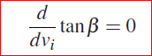
This occurs when
Differentiating equation 4 gives
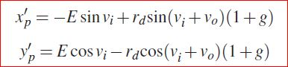
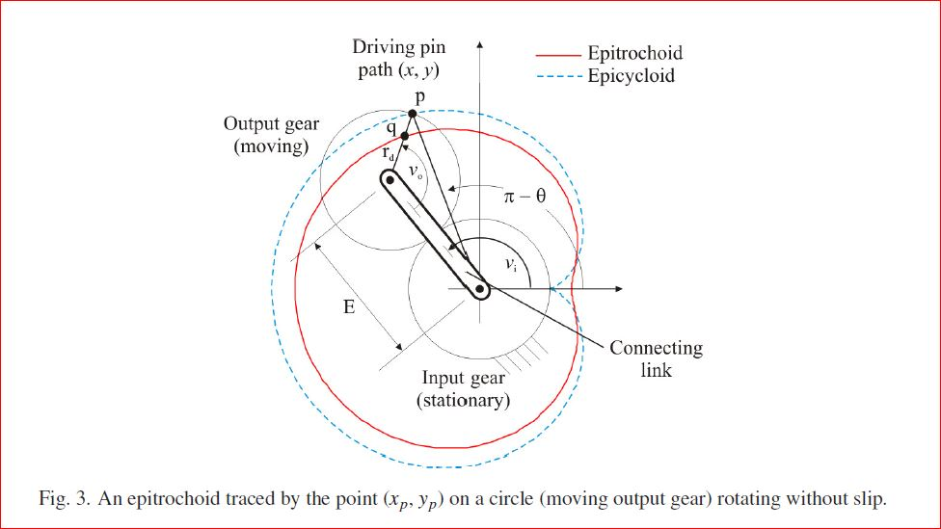
Fig. 3.8.2
where g ≡ dvo/dvi is defined as the instantaneous gear ratio. Differentiating the above gives
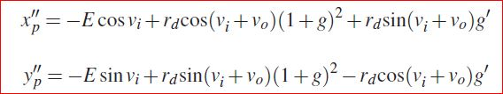

Candidate driving pin paths (xp, yp) are expressed in terms of the Instantaneous gear ratio g. Subsequently, g is expressed using a Fourier series with N terms as follows:
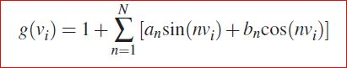
Where the coefficients an and bn (n = 1, . . . , N) are unknown variables to be determined. g is an “even” function in this case due to the symmetry of the Geneva wheel drive. The “evenness” enables the “odd” terms (viz., the sine terms) in the Fourier series to be ignored. Each function g is evaluated using the following integral relation:
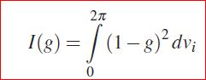
g = 1 = constant for circular gears. One of the N terms in the Fourier series together with vi are used to satisfy Eq. (5) and (7) simultaneously. The remaining N − 1 terms are optimized to minimize Eq. (11) yielding gears as circular as possible. This procedure was implemented and multiple solutions were obtained. How- ever, a feasible solution with acceptable non-circular gears (e.g., both gear elements remain convex) using a 1:1 net speed reduction was not obtained. One unacceptable solution is provided in Fig. 4.
A suitable driving pin path can be generated using circular gears. In this case, the instantaneous gear ratio g is constant for circular gears and g0 = 0. Depicted in Fig. 5 is an epitrochoidal path where the diameter of the input gear is three times bigger than the diameter of the moving gear. Also presented is a Geneva wheel with 6 slots (i.e., n = 6). Substituting Eq. (8–9) into Eq. (7) yields a relation for the radial distance rd. For
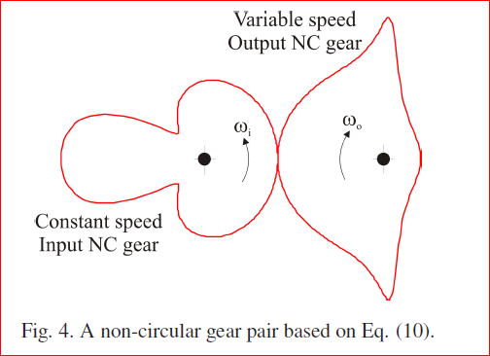

the special case where the fixed input gear is three times bigger than the output gear, the radial distance rd that ensures an inflection is (vo = gvi for circular gears)
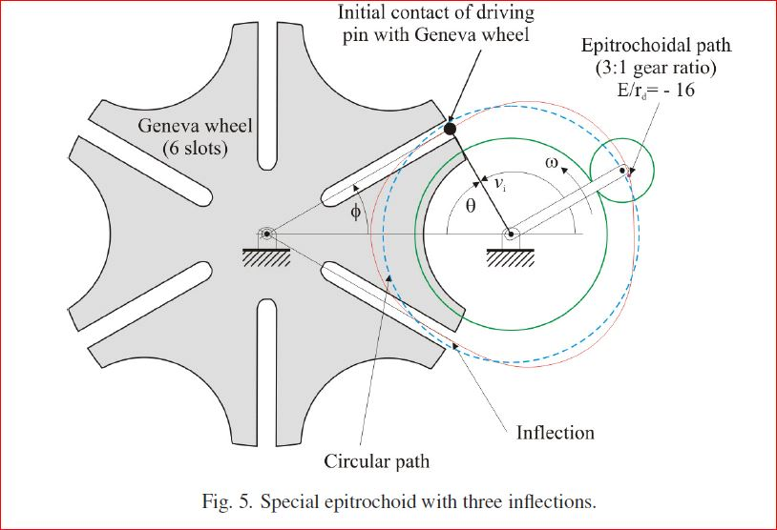
Fig 3.8.4
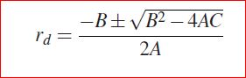
Where
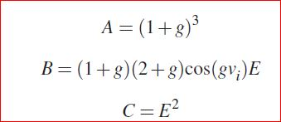
For n = 6, the gear ratio g = 3, vi = 120◦, and rd = −E/16. Additional combinations of n, g, and rp exist which satisfy Eq. 7.
3.9 MOTION COMPARISON:
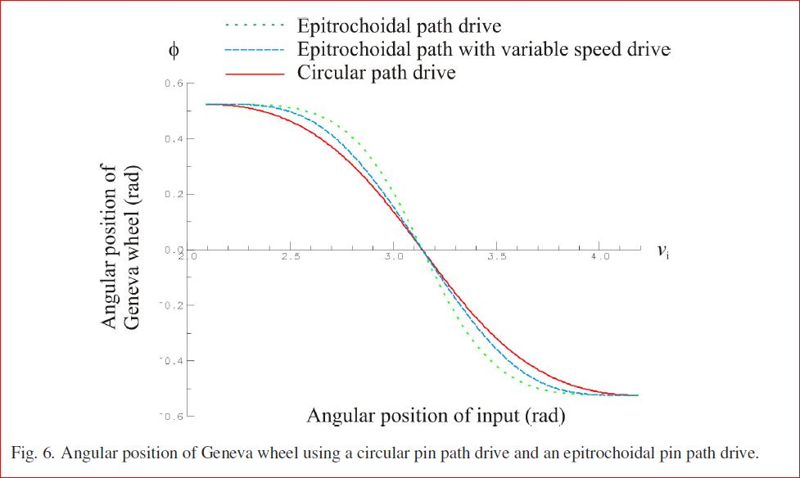
Figure 6 shows the functional relation between the angular position φ (Eq. 2) of the Geneva wheel versus the angular position vi of the input wheel for the classical case where the driving pin path is circular. Also shown is the angular position φ of the Geneva wheel versus the angular position vi of the connecting link for the case where the driving pin path is epitrochoidal. A third motion case involving a variable speed drive is presented that will be used in the next section. An evaluation of the Geneva wheel motion for the circular pin path drive and the epitrochoidal pin path drive is extended by comparing the kinematic velocity, acceleration, and jerk as presented in Figs.7, 8, and 9 respectively. The angular position vi is valid on the open interval (120◦, 240◦) and Figs.6, 7, and 8 do not consider the endpoints. This is especially important in Fig. 8 where a jerk spike exists at the endpoints for the circular path drive curve.
3.10 DESIGN PROCEDURE:
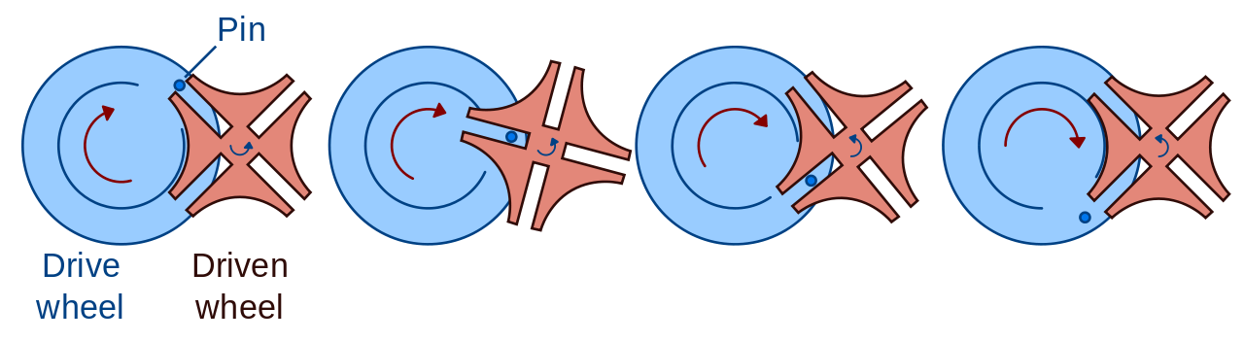
The wheel of 10cm radius was taken, on which a smaller wheel of 8cm radius was mounted, which is designed such that ¼ th part was removed so that the driven wheel will rotate in it. Both the circles are taken at a thickness of 30mm these two wheels acted as a single part. Driven wheel was designed by taking a wheel of radius 10cm and this wheel will have 4 grooves of depth 60mm which are perpendicular to each other. Take two centre lines which are perpendicular two each other and to the center take a distance of 10mm on either side in which the drive pin will move. And we need to cut the arc on four sides of the wheel taking the radius of the smaller circle of the driver wheel (ie.80mm). The driven wheel will be mounted on gap on the driver wheel. Such that the center point of the driven wheel and centre of the pin should be perfectly perpendicular to the starting point of the driven wheel. When the driven wheel was rotated the pin gets locked into the grooves of the driven wheel and hence the next groove will be coming to the position. For 360degrees of revolution of the driver wheel 90degrees of revolution was produced to the driven wheel.
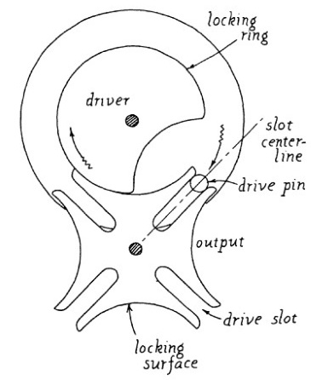

When this driven wheel was revolved for 90degrees the remaining 270degrees the driven wheel will be in rest position in contact with the driven wheel. This 90degrees of revolution will give the motion for the feed. This feed was carried out with the help of chain drive or with belt drive. This belt drive will produce intermittent motion or the motion which was taken by driven wheel from the driver wheel. Driven wheel and belt drive will rotate simultaneously with equal time because this belt drive rotates with the feed from the driven wheel.

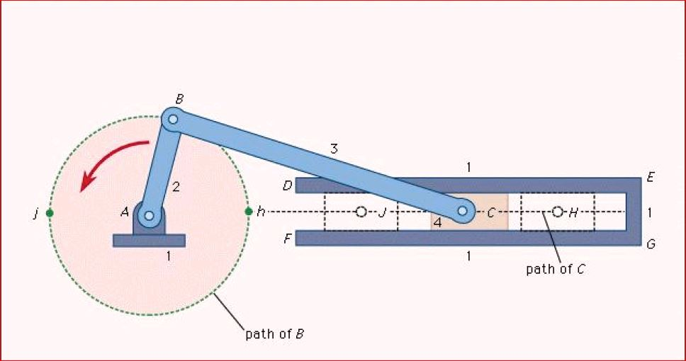
CHAPTER 4
4.1 INTRODUCTION TO SLIDER CRANK MECHANISM:
Slider-crank mechanism, arrangement of mechanical parts designed to covert straight line motion to rotary motion, as in a reciprocating piston engine, or to convert rotary motion to straight-line motion, as in a reciprocating piston pump. The basic nature of the mechanism and the relative motion of the parts can best be described with the aid of the accompanying figure, in which the moving parts are lightly shaded. The darkly shaded part 1, the fixed frame or block of the pump or engine, contains a cylinder, depicted in cross section by its walls DE and FG, in which the piston, part 4, slides back and front. The small circle at A represents the main crankshaft bearing, which is also in part 1. The crankshaft, part 2, is shown as a straight member extending from the main bearing at A to the crankpin bearing at B, which connects it to the connecting rod, part 3. The connecting
Fig 4.1
rod is shown as a straight member extending from the crankpin bearing at B, from the crankpin bearing at B to the wristpin bearing at C, which connects it to the piston, part 4, which is shown as a rectangle. The three bearings shown as circles at A,B and C permit the connected member to rotate freely with respect to one another. The path of B is a circle to radius AB; when B is at point h the piston will be in position H, and when B is at point j the piston will be in position j. On a gasoline engine, the head end of the cylinder (where the explosion of the gasoline-air mixture takes place) is at EG; the pressure produced by the explosion will the piston from position H to position j; return motion from J to H will require the rotational energy of a flywheel attached to the crankshaft and rotating about a bearing collinear with bearing A. On a reciprocating piston pump the crankshaft would be driven by a motor.
The slider crank mechanism is used to transform rotational motion into translational motion by means of a rotating driving beam, a connecting rod and a sliding body. In the present example, a flexible body is used for the connection rod. The sliding mass is not allowed to rotate and three revolute joints are used to connect the bodies. While each body has six degrees of freedom in space, the kinematic conditions lead to one degree of freedom for the whole system.
A slider crank mechanism converts circular motion of the crank into linear motion of the slider. In order for crank to rotate fully the condition L>R+E must be satisfied where R is the crank length, l is the length of the link connecting crank and slider and E is the offset of slider. A slider crank is a RRRP type of mechanism i.e. it has three revolute joints and 1 prismatic joint. The total distance covered by the slider between its two extreme positions is called the path length. Kinematic inversion of slider crank mechanism produces ordinary and white work quick return mechanism.
When the time required for the working stroke is greater than that of the return stroke, it is a quick return mechanism. It yields a significant improvement in machining productivity. Currently, it is widely used in machine tools, for instance, shaping machines, power-driven saws, and other applications requiring a working stroke with intensive loading, and a return stroke with non-intensive loading. Several quick return mechanisms can be found including the offset crank slider mechanism, the crank-shaper mechanisms, the double crank mechanisms, crank rocker mechanism and Whitworth mechanism. In mechanical design, the designer often has need of a linkage that provides a certain type of motion for the application in designing. Since linkages are the basic building blocks of almost all mechanisms, it is very important to understand how to design linkages for specific design characteristics. Therefore, the purpose of this project is to synthesize quick-return mechanism that converts rotational to translational motion.
4.1.1 Kinematic pairs:
The relative motion between two links of a pair can take different form. Three types of a pairs are known as lower pairs and these are the frequently occurring ones:
Sliding: such as occurs between a piston and a cylinder
Turning: such as occurs with a wheel on an axle
Screw motion: such as occurs between a nut and a bolt
All other cases are considered to be combinations of sliding and rolling are called higher pairs. Strictly screw motion is a higher pair as it combines turning and sliding.
4.2 CRANK AND SLOTTED LEVER QUICK RETURN MECHANISM:
This mechanism is mostly used in shaping machines, slotting machines and in rotary internal combustion engines. In this mechanism, the link AC (i.e., link 3) forming the turning pair is fixed, as shown in Figure 1. The link 3 corresponds to the connecting rod of a reciprocating steam engine. The driving crank CB revolves with uniform angular speed about the fixed centre C.
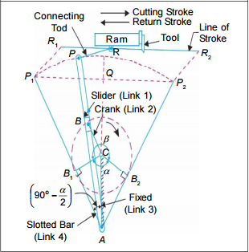

Fig 4.2 slotted quick return
A sliding block is attached to the crank pin at B slides along the slotted bar AP and thus causes AP to oscillate about the pivoted point A. A short link PR transmits the motion from AP to the ram which carries the tool and reciprocates along the line of stroke R1 R2.The line of stroke of the ram (i.e., R1 R2 ) is perpendicular to AC produced. In the extreme positions, AP1 and AP2 are tangential to the circle and the cutting tool is at the end of the stroke. The forward or cutting stroke occurs when the crank rotates from the position CB1 to CB2 (or through an angle β) in the clockwise direction. The return stroke occurs when the crank rotates from the position CB2 to CB1 (or through angleα) in the clockwise direction.
4.3 Determination of length of stroke and time ratio
Let ∠CAB1 = Inclination of the slotted bar with the vertical.
Fig 4.3 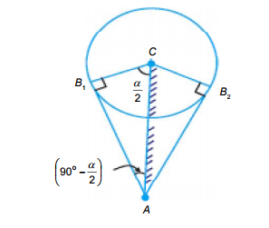
We know that
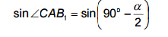
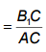
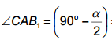
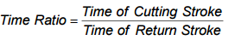

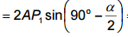
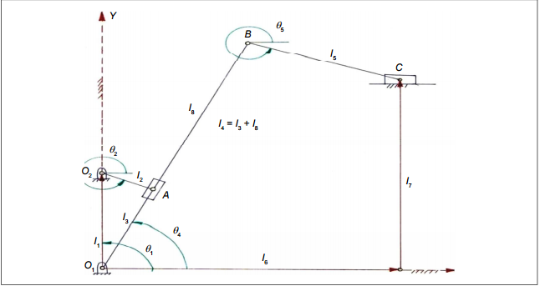
Fig 4.3.1 Vector representation of crank and slotted lever quick return mechanism
Looking at Figure the crank and slotted lever quick return mechanism can be broken up into multiple vectors and two loops. Utilizing these two loops, the following sections will go through the kinematic analysis of the Crank and slotted lever Quick Return Mechanism.

4.4 POSITION ANALYSIS:
For the Crank and slotted lever Quick Return Mechanism shown in Figure, the displacement analysis can be formulated by the following loop-closer equations
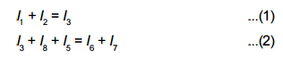
Using complex numbers, equations (I and 2) becomes
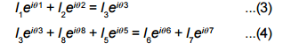
Where the link lengths l1 , l2 , l5 , l7 and angular positions θ1 , θ6 and θ7 are constants. Angular position θ2 is an independent variable; angular positions θ3, θ8, θ4 and θ5 are dependent variables.
From figure θ 8 = θ 3 = θ 4 and l4 = l3 + l 8
Substituting and rearranging Equations (1 and 2);
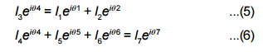
As Equation (5) has 2 unknowns and Equation (6) has 3 unknowns,
Utilizing Euler’s equation, eiθ = cosθ + isinθ
l3 cosθ4 + isinθ4 = l1 cosθ1 + isinθ1 + l2 cosθ2 + isinθ2
Separate this equation in real numbers and imaginary numbers.
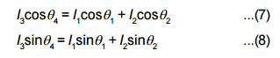
Squaring Equations (7 and 8) and adding them together;
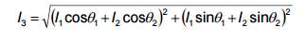…... (9)
Dividing Equation (8) by Equation (7) and simplifying gives
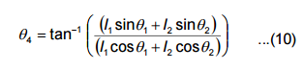
By knowing the value of θ4 , Equation (6) has only 2 unknown values,
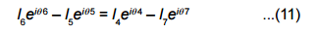
Since right hand side of Equation (11) is constant
Let,
leiθ = l4 eiθ4 – l7 eiθ7
Again break the equation into real and imaginary part,
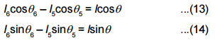
By solving Equations (13 and 14),
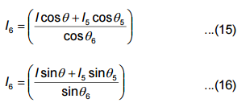
Where Equation (15) is used when cosθ6 > 0 and Equation (16) is used when cosθ6 = 0
Put Equation (15) in Equation (14)
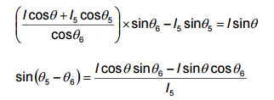
Solving for θ5, we get
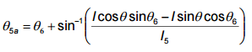
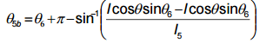
By knowing all of the angular positions and the length of l6, we can find the position of the output slider C by using
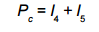
4.5 Design procedure:
It is a four bar mechanism.so it require four links connected in a loop by one degree of freedom joints. A joint may be either a revolute, that is a hinged joint, denoted as a prismatic, as sliding joint.
A link connected to ground by a hinged joint is usually called crank. A link connected to ground by a prismatic joint is called slider. Sliders are sometime considered to be cranks
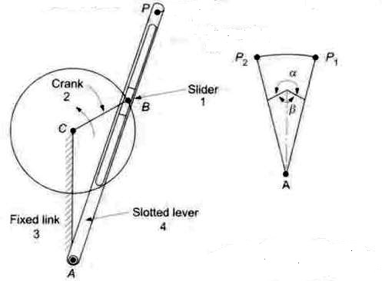
Fig 4.5 layout of slotted lever mechanism
that have a hinged pivot at an extremely long distance away perpendicular to the travel of the slider. The link that connects two cranks and a slider, it is often called a connecting rod.
The one end of the slider was connected to the fixed link and other was let free. The crank was rotated continuously and the slider was rotated in the slotted portion and thus produces the oscillation motion which is used for the cutting purpose.

CHAPTER 5
5.1 INTRODUCTION TO BELT DRIVE:
The belts are used to transmit power from one shaft to another shaft by means of pulleys which rotate at a speed or at different speeds. The amount of power transmitted depends upon the following factors:
- The velocity of the belt.
- The tension under which the belt is placed on the pulleys.
- The arc of contact under which the belt is used
The belt drives are usually classified into the following three groups:
1. Light drives:
These are used to transmit small powers at belt speeds up to about 10 m/s as in agricultural machines and small machine tools.
2. Medium drives:
These are used to transmit medium powers at belt speeds over 10 m/s but up to 22 m/s, as in machine tools.
3. Heavy drives:.
These are used to transmit large powers at belt speeds above 22 m/s as in compressors and generators.

5.2 TYPES OF BELTS:
There are three main types of belts:
- Flat belt:
The flat belt as shown in Fig, is mostly used in the factories and workshops, where a moderate amount of power is to be transmitted, from one pulley to another when the two pulleys are not more than 8 meters apart.

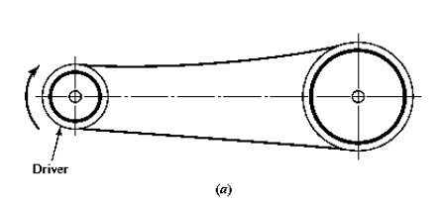
Fig 5.5.1
- V-belt:
The V-belt as shown in Fig is mostly used in the factories and workshops, where a great amount of power is to be transmitted, from one pulley to another, when the two pulleys are very near to each other.
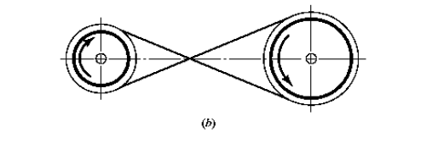
Fig 5.2.2 V belt
- Circular belt:
The circular belt or rope as shown in Fig is mostly used in the factories and workshops, where a great amount of power is to be transmitted, from one pulley to another, when the two pulleys are more than 8 meters apart.
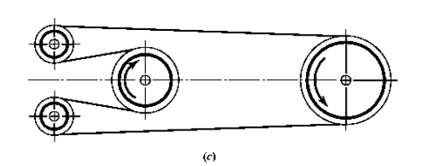
Fig 5.2.3 Circular belt

Open belt geometry:
Where:
d = diameter of small pulley
D= diameter of large pulley
C = center distance
θ = angle of contact

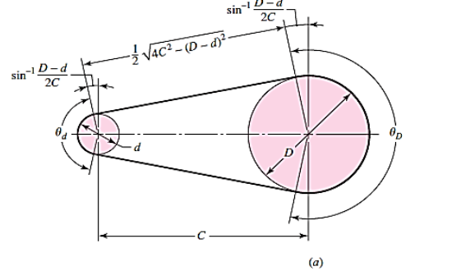
Fig 5.2.4 Open Belt Drive
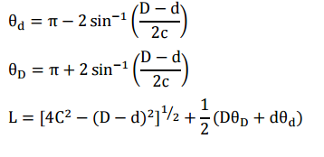

Crossed belt geometry:
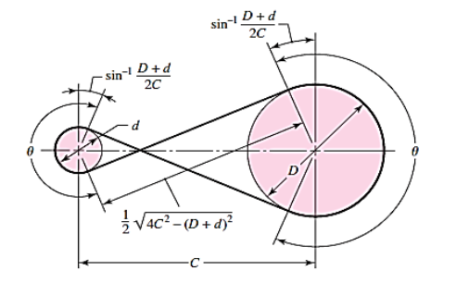

Where:
d = diameter of small pulley
D= diameter of large pulley
C = center distance
θ = angle of contact
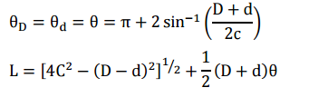
So we considered flat belt for the project because equipment need to withhold the stress produced. The design procedure was not so complex and easy to remove whenever required. The center distance between the two pulleys was maintained 35cms. One end of the belt was connected to the shaft of driven wheel because the feed from the Geneva need to be carried out and this shaft acts as the pulley to the belt.

CHAPTER 6
6.1 SOLIDWORKS:
The SolidWorks CAD software is a mechanical design automation application that lets designers quickly sketch out ideas, experiment with features and dimensions, and produce models and detailed drawings.
6.2 CONCEPT:
Parts are the basic building blocks in the SolidWorks software. Assemblies contain parts or other assemblies, called subassemblies. A SolidWorks model consists of 3D geometry that defines its edges, faces, and surfaces. The SolidWorks software lets you design models quickly and precisely.
SolidWorks models are
- Defined by 3D design
- Based on components
3D Design SolidWorks uses a 3D design approach. As you design a part, from the initial sketch to the final result, you create a 3D model. From this model, you can create 2D drawings or mate components consisting of parts or subassemblies to create 3D assemblies. You can also create 2D drawings of 3D assemblies. When designing a model using SolidWorks, you can visualize it in three dimensions, the way the model exists once it is manufactured.
6.3 DESIGN PROCESS:
The design process usually involves the following steps
- Identify the model requirements.
- Conceptualize the model based on the identified needs.
- Develop the model based on the concepts.
- Analyse the model.
- Prototype the model.
- Construct the model.
- Edit the model, if needed
6.4 DESIGN METHOD:
Before you actually design the model, it is helpful to plan out a method of how to create the model. After you identify needs and isolate the appropriate concepts, you can develop the model:

6.4.1 Sketch:
Create the sketches and decide how to dimension and where to apply relations. Select the appropriate features, such as extrudes and fillets, determine the best features to apply, and decide in what order to apply those features.
6.4.2 Features:
Select the appropriate features, such as extrudes and fillets, determine the best features to apply, and decide in what order to apply those features.
6.4.3 Assemblies:
Select the components to mate and the types of mates to apply.
6.4.4 Modeling:
3D solid modeling with SOLIDWORKS speeds the creation of complex parts and large assemblies.3D modelling improves visualization and communication, eliminates design interference issues and speeds design development and detailing. Creates 3D solid models of any part and assembly no matter how large or complex, quickly makes variations of your designs by controlling key design parameters, Generate surfacing for any 3D geometry, even complex organic and stylized shape.
6.5 COMMANDS USED IN SOLIDWORKS:
6.5.1 Sketch:
With this command we used to design the required outlet or shape of the model. In this we can see only two axis, x axis and y axis.
6.5.2 Extrude:
Using this command we can get the required width to the model drawn in the sketch. Which means we can get all the three axis, x axis, y axis and z axis.
6.5.3 Trim:
In the sketch we design the closed objects but we want the semi closed objects using this command we can trim the unrequired parts and parts which are unnecessary closed to the required model can be trim using power trim.
6.5.4 Mirror entities:
Usually in closed objects we require equal length objects in all the directions. So we can use mirror entities command to get the same object with the same dimensions in other side. This can be done by taking a center line and using this command we can complete the work more easily.
6.5.5 Assembly module:
In this module all the parts designed in the part module using the required commands are inserted and all these are assembled to the required shape and motion can be produce in this module by using the motion study.
6.5.6 Mate:
Components inserted in the assembly module are assembled using the required mates to make the component join and revolve to the required mates.

6.6 DESIGN PROCEDURE IN SOLID WORKS:
6.6.1 Geneva mechanism:
During the initial stages of the design we need to design the driven wheel and driver wheel in the part module to the required dimensions for the Geneva mechanism. Then we need to slowly start belt drive and pulleys used for the belt drive.
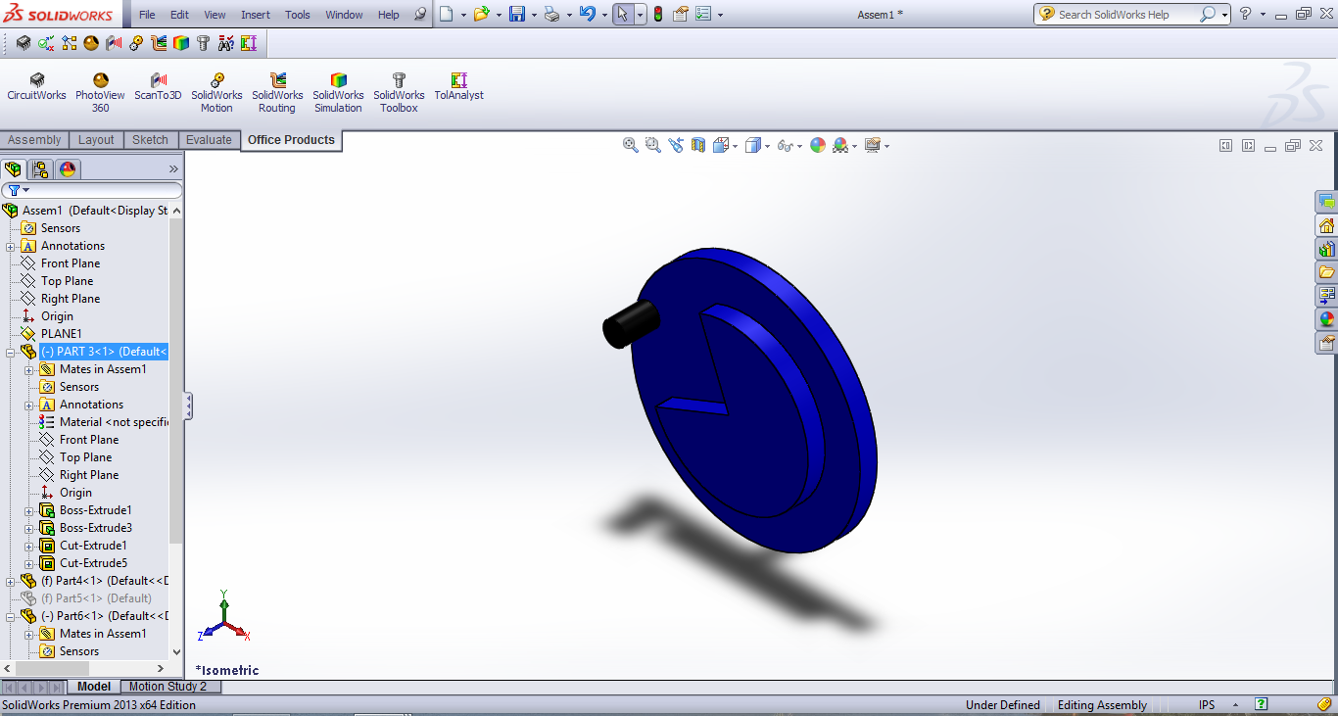
Fig 6.6.1(a) solidworks model of Geneva wheel
Then all the components designed in the part module are inserted in the assembly module and all are assembled in the required dimensions using the mates such as advanced mates and mechanical mates.
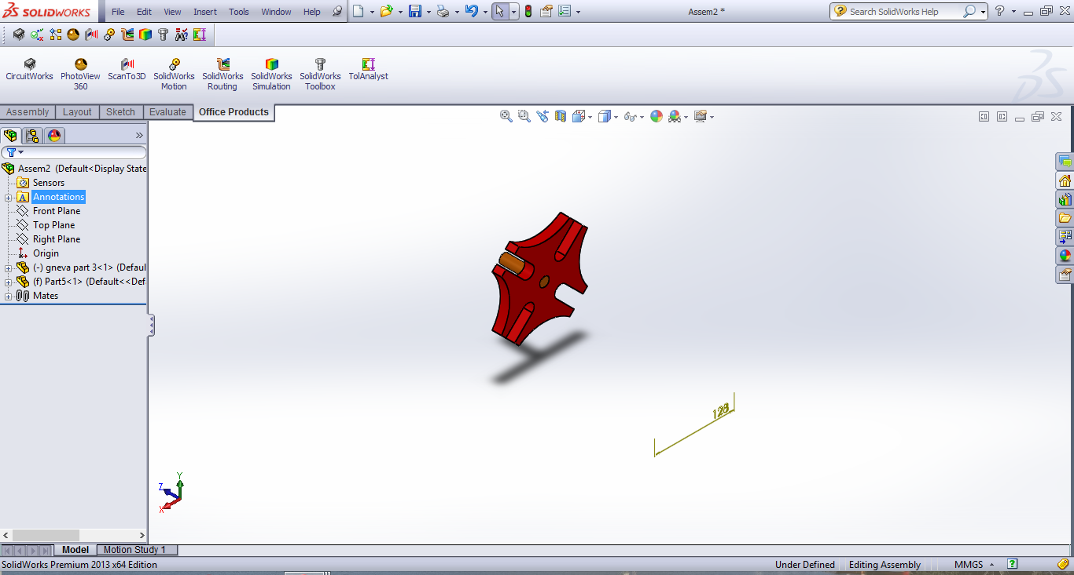
Fig 6.6.1(b) solidworks model of driven wheel of Geneva Mechanism
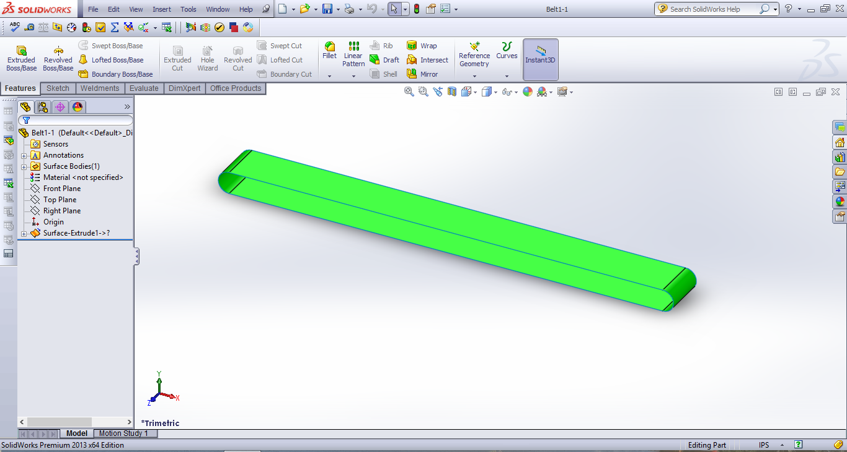
Fig 6.6.1© solidworks model of Belt Drive
Then the assembled component was inserted in the motion study and the motion was given to the driven wheel and this driven wheel will rotate the driver wheel and produced the rotation motion to the belt drive and thus produces the feed to the required length.
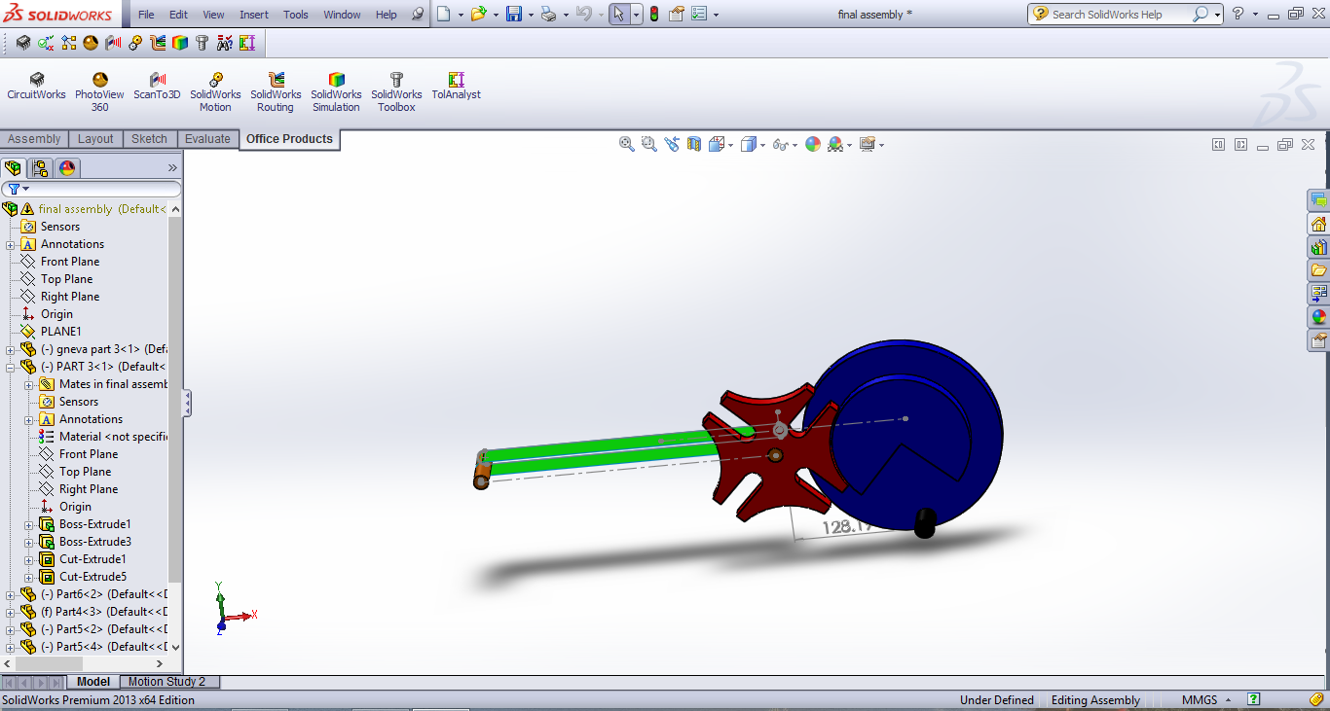
Fig 6.6.1(d) Total assembly of the Geneva Mechanism
6.6.2 Slotted lever mechanism:
First of all we need to design the I section, diver wheel and the crank shaft in the part module individually. Then one by one we design them using the extrude command and design them to the required dimensions.
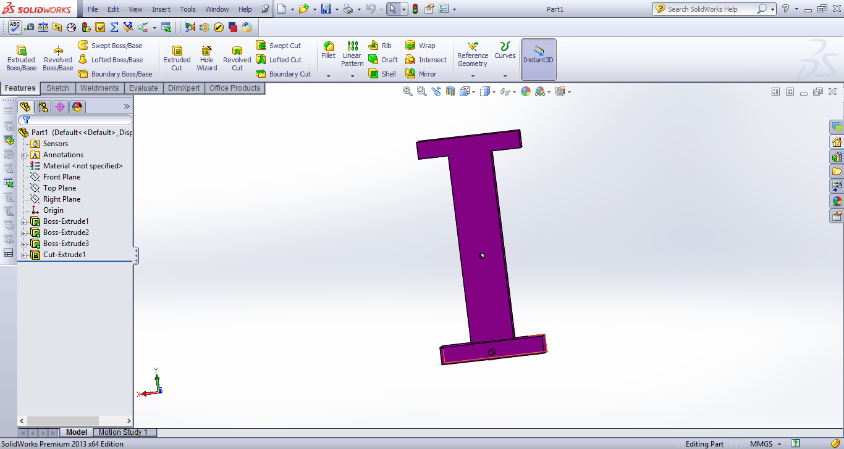
Fig 6.6.2(a) solidworks model of I section
Then all the components are inserted in the assembly command and using the mates we design the requires assembly and the then check whether there are any errors in the assembly or in the part and boss extrude. Because if any errors are there the simulation was not able to work.
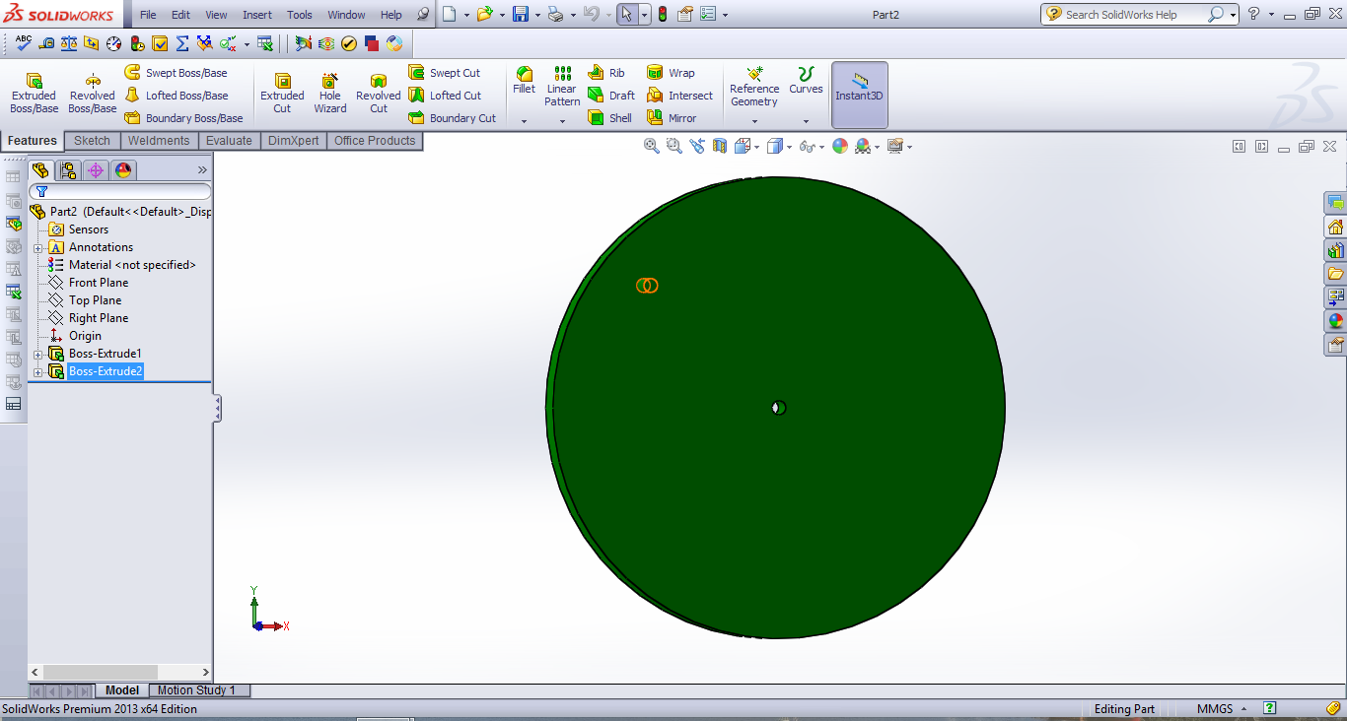
Fig 6.6.2(b) solidwork model of crank

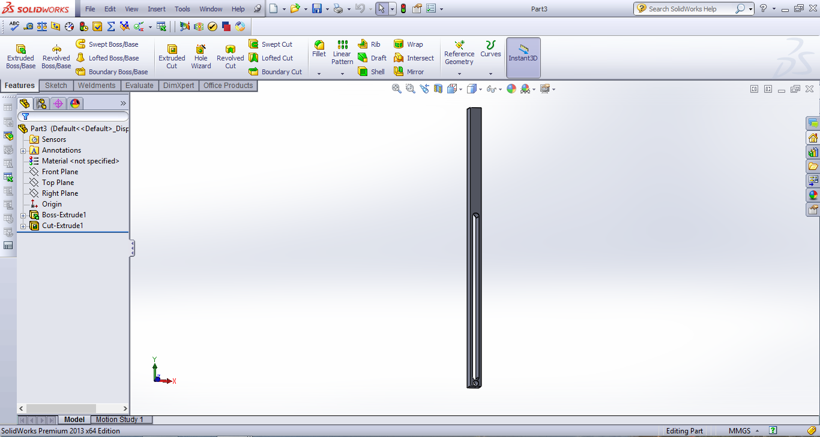
Fig 6.6.2© solidworks model of slider
After assembling all the parts the motion study was conducted. Motor was given to the disk and then the crank should oscillate when the disk rotates. After assembling all the components and the motion study analysis are calculated for both the mechanisms.
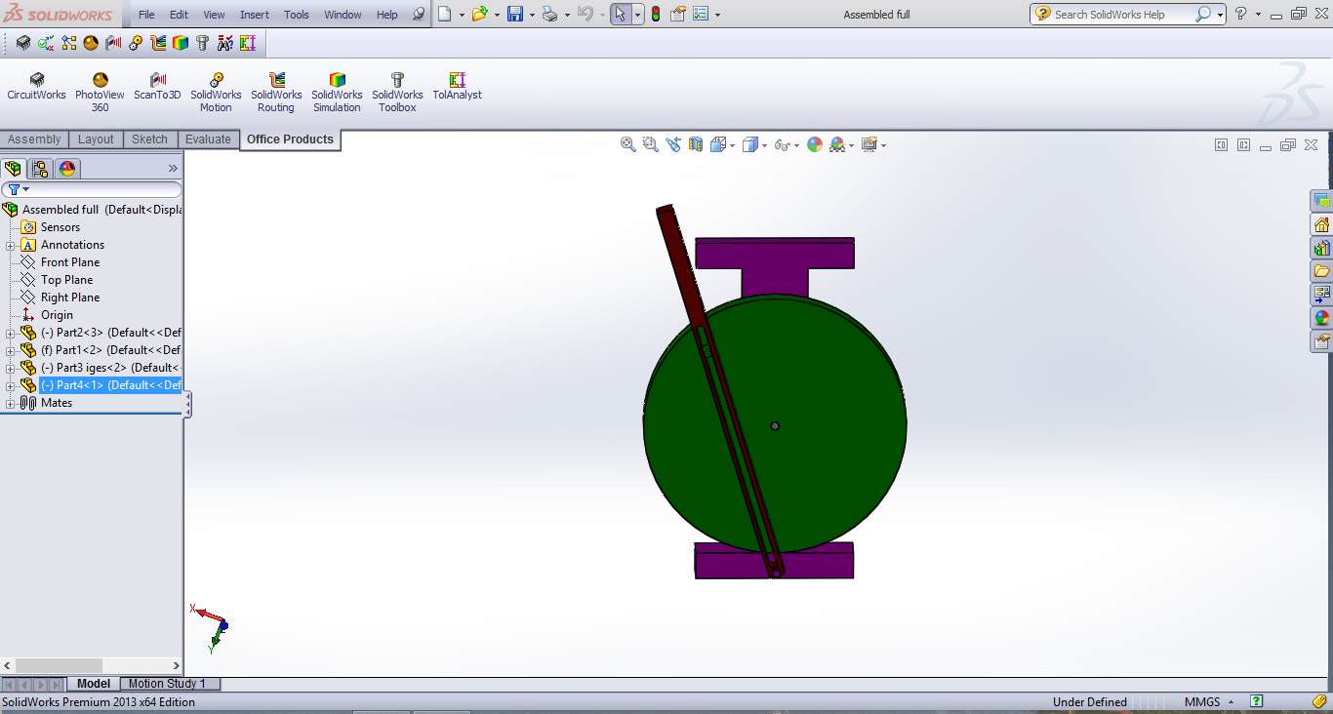
Fig 6.6.2(d) solidworks assembly model of slider crank mechanism
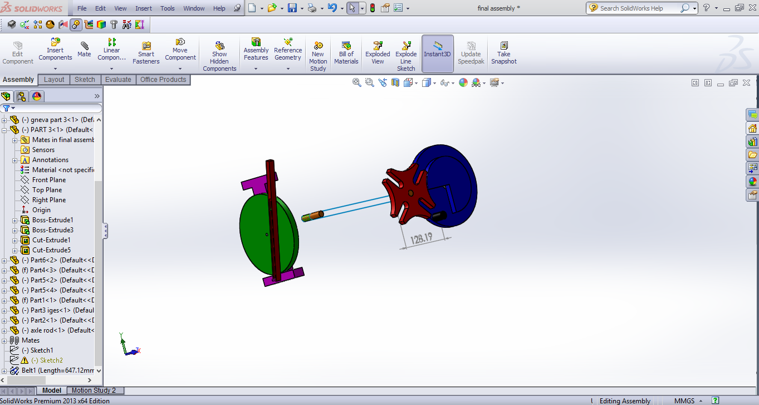
Fig 6.6.3(e) solidworks assembly of Geneva and slider crank mechanism

CHAPTER 7
7. KINEMATIC ANALYSIS:
As the feed produced by the Geneva mechanism was carried out with the help of the belt drive. The feed came from the belt will be holding in rest until the pin on the driver pulley get contact with the groove of the driven pulley. The slotted lever mechanism which was designed from the principle of slider crank mechanism was placed perpendicular to the output from the Geneva mechanism. The edge of the crank was having a blade and its contact to the feed when the crank starts oscillating with respect to the crank wheel.
So the feed from the Geneva mechanism was cut at regular interval of time. We need to calculate kinematic analysis for both slotted lever mechanism and Geneva mechanism. We need to calculate angular velocity and angular displacement for both the mechanisms.
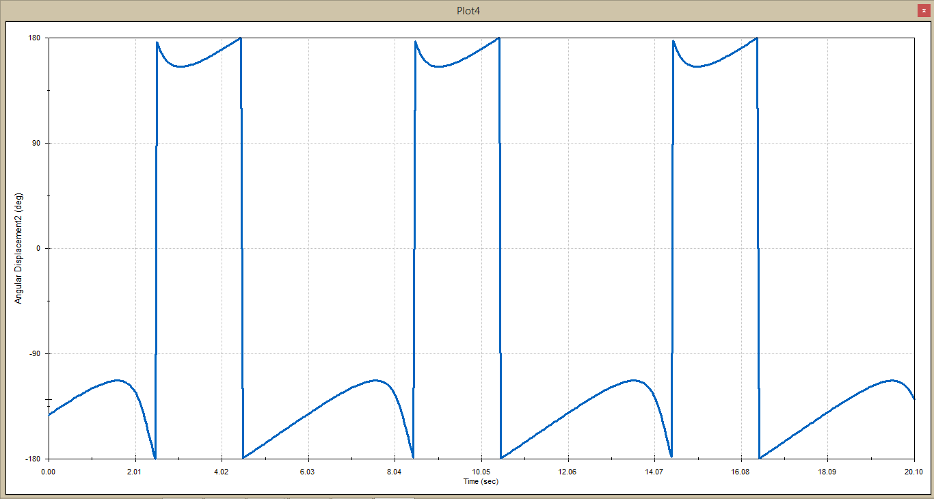
Graph 7.1.Angular displacement for slider
From graphs 7.1 and 7.2 we find out the angular displacement and angular velocity for slider with respect to the time. From graph 7.1 is observed that he angular displacement was more in the return stroke than in the forward stroke and it is also same with angular velocity which is shown in graph 7.2, the velocity of the slider was more in the return stroke than in the forward stroke.

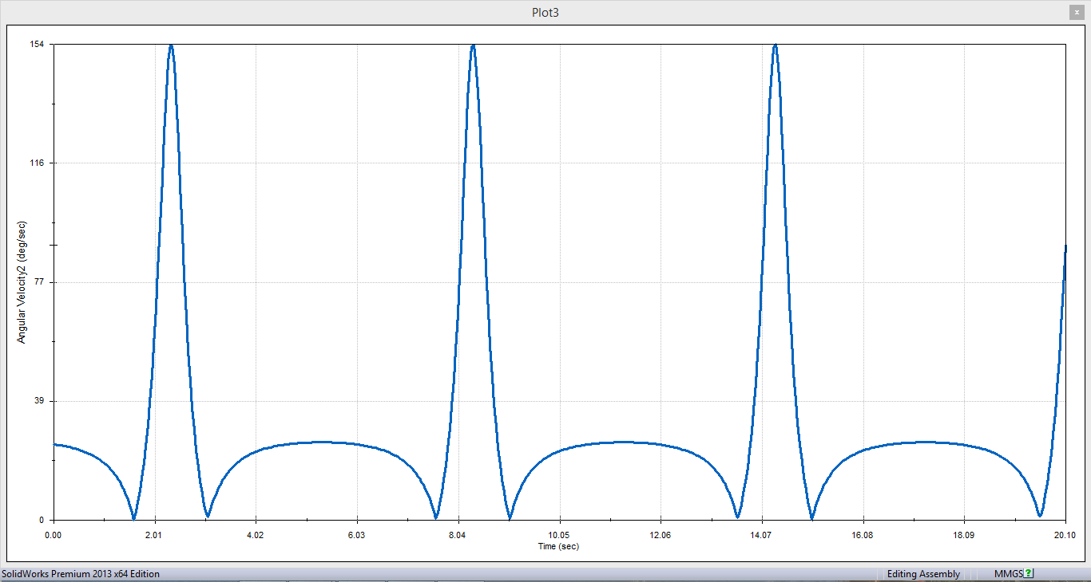
Graph 7.2.Angular velocity for slider

Angular displacement and angular velocity of the crank in the slider crank mechanism was observed with respect to time shown in graphs7.3 and 7.4

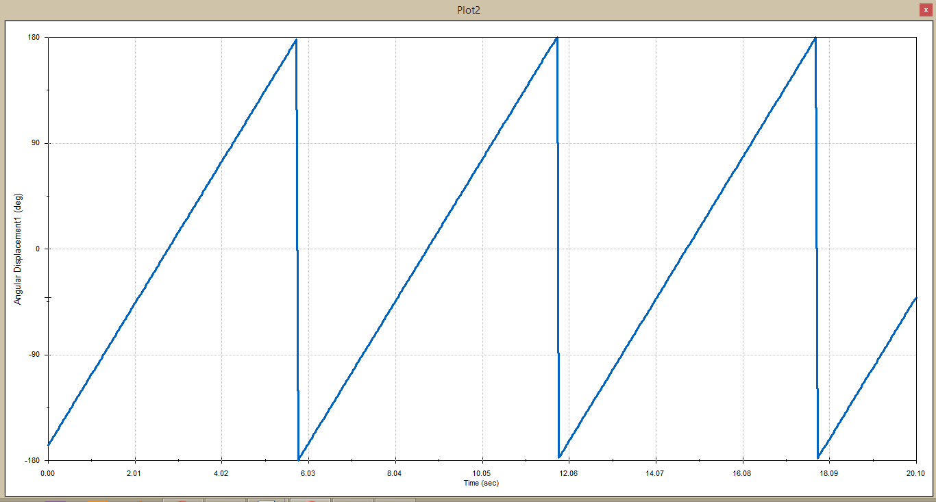
Graph 7.3.Angular Displacement for crank

From graph 7.3 the angular displacement of the crank gradually increases from 0° to 180° of rotation and from then it remains constant till the completion of rotation of crank. Whereas from graph 7.4 the angular velocity of the crank remains constant throughout the rotation of the crank.

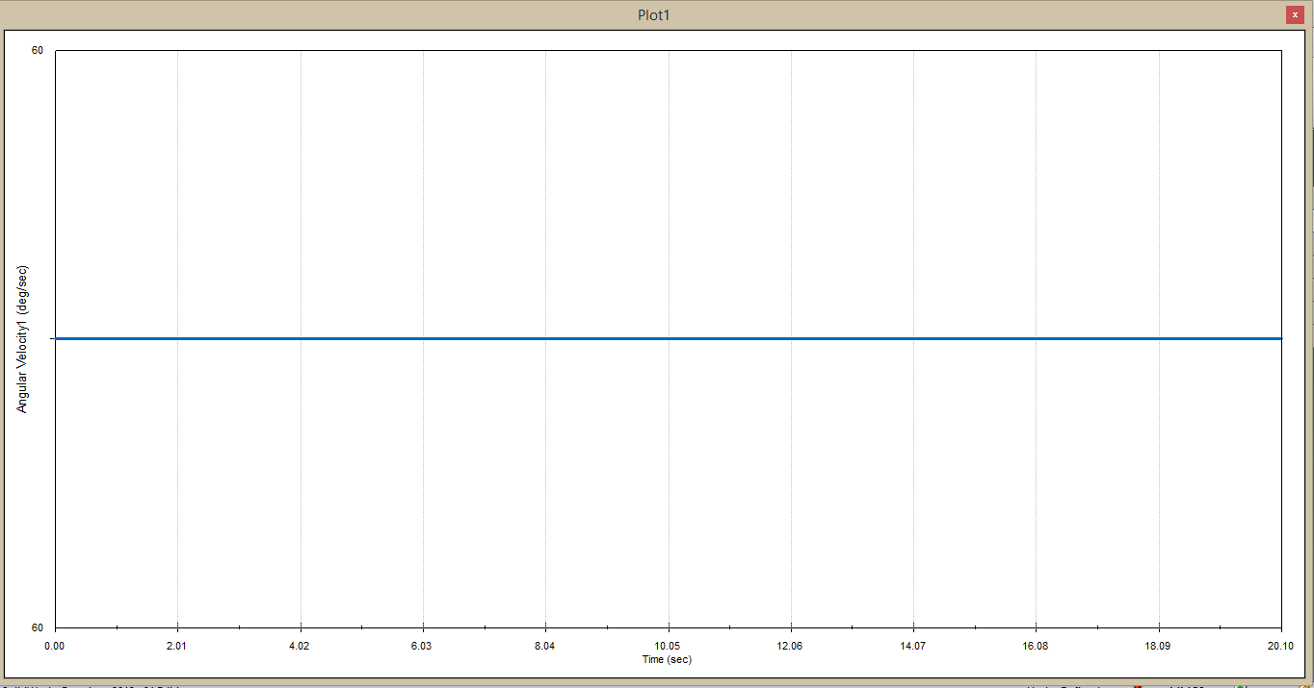
Graph 7.4.Angular velocity for crank

Similarly angular displacement and angular velocity for driven wheel in Geneva mechanism with respect to the time as shown in graphs 7.5 and 7.6
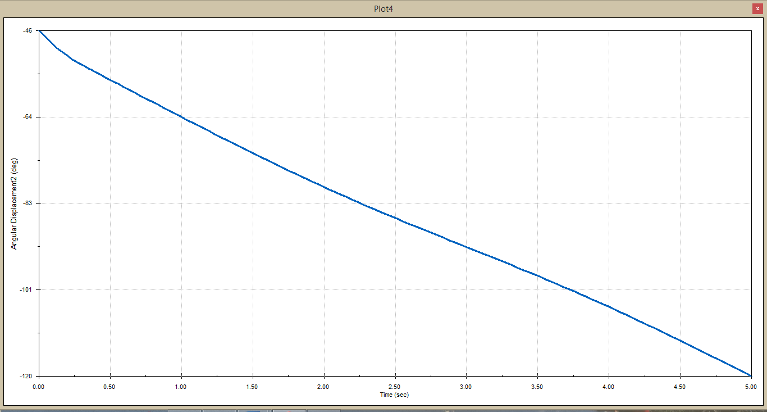
Graph 7.5.Angular displacement for driver wheel in Geneva mechanism

From the graph 7.5 we can get the angular displacement for driven wheel. The angular displacement gradually decreases because the wheel having some jerks when locking is done with the Geneva wheel. In graph 7.6 we can observe that the angular velocity gradually falls at a certain point and then it rises this happens due to the jerks caused when interlocking of pin with the Geneva wheel.
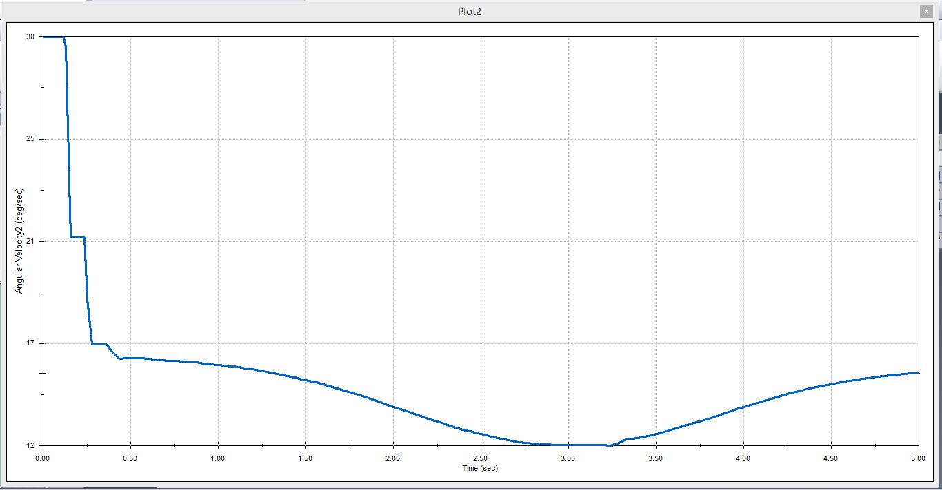
Graph 7.6.Angular velocity for driver wheel in Geneva mechanism

The graph 7.7 and 7.8 shows the angular displacement and angular velocity of the Geneva wheel. From 7.7 the angular displacement of the Geneva wheel having a slight drop in the beginning due to locking and then it gradually increases till the unlocking of the pin.

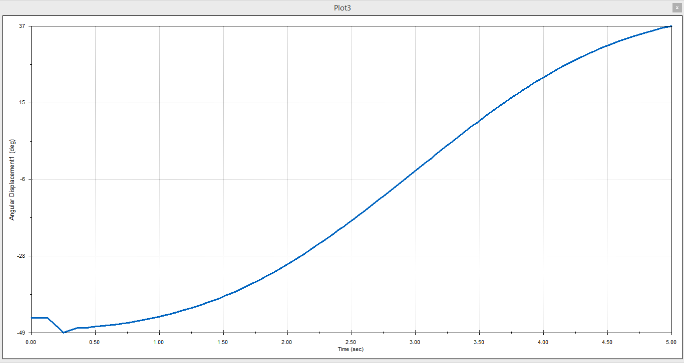
Graph 7.7.Angular displacement of Geneva wheel
The graph 7.8 shows that the angular velocity will be constant till the locking and then it gradually increases till the unlocking of pin after it will be gradually dropping.

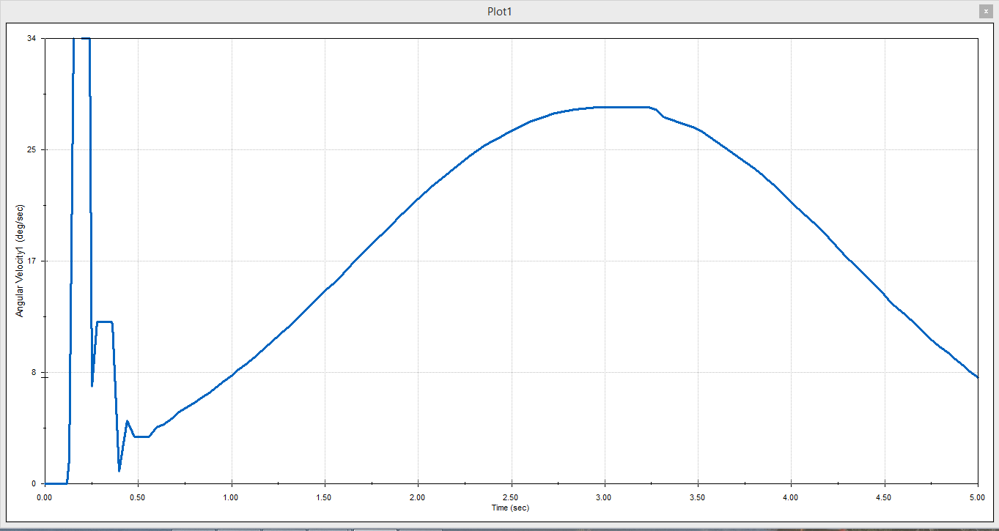
Graph 7.8.Angular velocity of Geneva wheel

CONCLUSION:
The feed which came from the Geneva mechanism carried by the belt drive was cut by the slotted lever mechanism which is at the end of the belt drive. With this model we can get the equal length of feed at equal interval of time. The length of the feed can be managed by changing the depth of the slots in Geneva wheel and the path length of the slider can be increased by increasing the radius of the crank and the length of the slot on the slider. The angular velocity and angular displacement are observed for each link by designing the entire model in solidworks and then calculated the analysis for each link.
FUTURE SCOPE:
In this project we used two motors for two mechanisms i.e. Geneva mechanism and slotted lever mechanism. In future we can decrease the cost and usage of the material by using a single motor for two drives and we can reduce the jerks in the Geneva wheel.

REFERENCE:
- Liu, J. Y., Chang, S.L. and Mundo, D., “Study on the use of a non-circular gear train for the generation of figure 8 patterns”, proceeding of the institution of mechanical engineers, Part C, journal of Mechanical Engineering science, Vol. 220, No. 8, pp.1229-1236, 2006.
- Gabrera J.A., Simon A, and Prado M.”Optimal synthesis of mechanism with genetic algorithms”. Mechanisms and Machine theory, Vol. 37, pp.1165-1177, 2000.
- Figliolini, G. and Angeles, J., “Synthesis of conjugate Geneva mechanisms with curved slots”, mechanism and machine theory, Vol.37, pp.1043-1061, 2002.
- A.N. Kounadis, “A qualitative analysis for the local and global dynamic buckling and stability of autonomous discrete system, journal of mechanics and applied mathematics 269-295”.
- J.L. Ha, R.F. Fung, K.Y. Chen, S.C. Hsien, “Dynamic Modeling and identification of a slider-crank with a flexible supports and non-identical forcing, non-linear dynamics”, 35 (2004) 205-227.
- I. Goudas, I. Stavrakis, S. Natsiavas, “Dynamics of slider-crank mechanism”, Journal of sound and vibration 289 (4-5) (2006)1019-1044.
- Waldron, K.J. and Kinzel, G.L., Kinematics, Dynamics, and Design of Machinery (2nd ed.), John Wiley and Sons, New York, 2004
- Zhang, C., Norton, R.L. and Hammonds, T., “Optimization of parameters for specified path generation using an atlas of coupler curves of geared five-bar linkages,” Mechanisms and Machine Theory, Vol. 19, pp. 459–466, 1984.
- Zbikowski, R., Galinski, C. and Pedersen, C.B., “Four-bar linkage mechanism for insect like flapping wings in hover: Concept and an outline of its realization”, Journal of Mechanical Design, Vol. 127, pp. 817–824, July 2005.
- P. Metallidis, S. Natsiavas, Linear and nonlinear dynamics of reciprocating engines, International Journal of Non-Linear Mechanics 38 (2003) 723–738.
- J.S. Chen, C.L. Huang, Dynamic analysis of flexible slider–crank mechanisms with non-linear finite element method, Journal of Sound and Vibration 246 (3) (2001) 389–402.
- D.S. Sophianopoulos, Static and dynamic stability of a single-degree-of-freedom autonomous system with distinct critical points, Structural Engineering and Mechanics 4 (5) (1996) 529-540.
- A.N. Kounadis, Nonlinear dynamic buckling of a simple model via the Liapunov direct method, Journal of Sound and Vibration 193 (5) (1996) 1091-1097.
- P.F. Byrd, M.D. Friedman, Handbook of Elliptic Integrals for Engineers and Physicists, Springer-Verlag, Berlin, 1954.

