Lewis Structures and Stoichiometry
Hands-On Labs, Inc.
Version 42-0080-00-02
Lab Report Assistant
Molecular Modeling and Lewis Structures
Exercise 1: Lewis Structures and Molecular Modeling
Practice questions from Part 1: Practice Describing Molecular Structures (Answers Provided)
Number of Valence Electrons:
- How many valence electrons does CHO₂⁻ have? Use the periodic table to calculate the total.
Answer: 18 electrons. Carbon is in group IV of the periodic table; hydrogen is in group I; oxygen is in group VI. The negative charge indicates the presence of an additional electron. Thus, C + H + O₂ + e- = 4 + 1 + (2)6 + 1 = 18 The total number of valence electrons in CHO₂ ⁻ is 18.
Lewis Structures:
- What is the Lewis structure for CHO₂⁻ ?
Hint: CHO₂⁻ has resonance structures, and there are two forms of the drawn molecule. Draw both structures.
Answer: 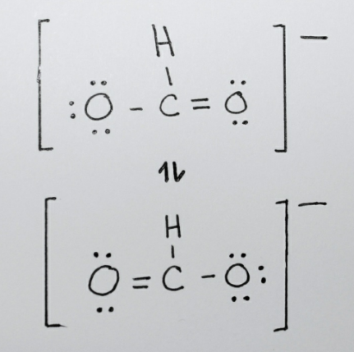
VSEPR Models:
- Use your molecular modeling kit to create a CHO₂⁻ molecule. Although the molecule has two Lewis structures, you only need to build one molecule.
Note: Consult Table 1 to determine which pieces represent the C, H, and O atoms. To create a double bond, use TWO of the long, flexible gray connectors. To create a single bond, use one of the short, inflexible connectors. Pink paddles represent lone pairs. The completed molecule should have no “open” or unfilled holes.
Answer: 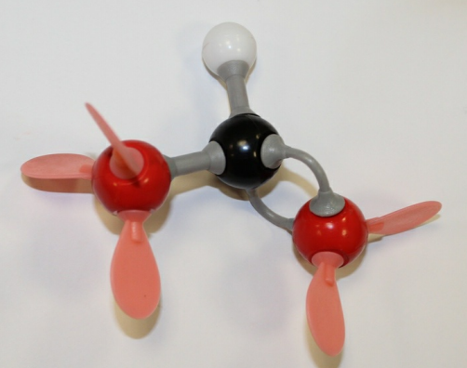
Atoms:
- What is the central atom? If there is more than one interior atom, list each.
Answer: Carbon
There is only one central (or interior) atom in this molecule. The carbon atom in the middle is the central atom- it is surrounded by two oxygen atoms and one hydrogen atom.
- How many bonds and electron pairs surround the central atom(s)?
Answer: 3
Carbon is surrounded by a total of three bonds: 1 double bond + 2 single bonds. A double bond contains 4 electrons; a single bond contains 2 electrons. There are no lone pairs around the carbon atom.
Since the molecule only has one central atom, only one description is needed.
Geometry:
- Identify the molecular geometry of the molecule. Refer to Figure 11 as needed.
Answer: Trigonal planar
The central atom of CHO₂⁻ is carbon. By comparing the structure around the carbon atom to the diagrams in Figure 11, it may be concluded that the molecular geometry is trigonal planar. Note that lone pairs (pink paddles) are disregarded when determining the molecular geometry.
Since the molecule only has one central atom, there is only one geometry. For molecules with more than one internal atom, more than one geometry must be identified.
Data Table 1. Lewis Structure and Molecular Model.
Insert the pictures of each molecular model in the VSEPR Model column. Please make sure that each picture includes your photo ID. Please also make sure the Lewis structures are hand drawn (not copied/pasted from the internet) and include your HANDWRITTEN name and date on the drawing itself. You are welcome to draw all of the Lewis structures onto one piece of paper (just make sure to identify each molecule) and take a picture/insert separately.
Molecule or Ionic Compound | # of Valence Electrons | Lewis Structure | VSEPR Model
AlCl₃
F₂
H₂O
[OCN]⁻
MgI₂
H₂O₂
CH₄
C₂H₄
CH₂O
CH₃OH
CH₃NH₂
NF₃
CO₂
[NH₄]⁺
[NO₂]⁻
PbI₂
OF₂
H₂S
SF₆
ICl₅

Data Table 2. VSEPR Names and Atoms. List the central atom followed by the number of atoms and lone pairs surrounding that central atom (see the example). Then provide the geometry around the central atom. For molecules that contain more than one central atom, please provide the info for each central atom.
Molecule | Central atom and number of atoms and/or sets of lone pairs surrounding central atom | Structure Geometry (Name)
Example: H₂O | Central atom = Oxygen  Atoms surrounding central atom = 2  Lone pairs surrounding central atom = 2 | Bent
AlCl₃
F₂
H₂O
[OCN]⁻
MgI₂
H₂O₂
CH₄
C₂H₄
CH₂O
CH₃OH
CH₃NH₂
NF₃
CO₂
[NH₄]⁺
[NO₂]⁻
PbI₂
OF₂
H₂S
SF₆
ICl₅

Questions
- List all of the molecules in Exercise 1 that had resonance structures. How many resonance structures did each molecule have?

- List all of the possible geometric structures of a molecule that contains a total of six atoms (don’t forget, there can also be lone pairs).

- What is the geometry of BeH₂? What is the geometry of [H₂Br]⁺? Considering that both molecules consist of 3 atoms, explain why they have different geometries.
Stoichiometry of a Precipitation Reaction
Exercise 1: Stoichiometry and a Precipitation Reaction
Data Table 1. Stoichiometry Values.
Initial: CaCl₂•2H₂O (g)
Initial: CaCl₂•2H₂O (moles)
Initial: CaCl₂ (moles)
Initial: Na₂CO₃ (moles)
Initial: Na₂CO₃ (g)
Theoretical: CaCO₃ (g)
Mass of Filter paper (g)
Mass of Filter Paper + CaCO₃ (g)
Actual: CaCO₃ (g)
% Yield:

Questions
- A perfect percent yield would be 100%. Based on your results, describe your degree of accuracy and suggest possible sources of error.

Using the following equation, answer questions B-E:
Al₂(SO₃)₃(aq) + KOH(aq) Al(OH)₃(s) + K₂SO₃(aq)

- Write the complete balanced equation.

- If you start with 2.8 g of Al₂(SO₃)₃, how many grams of KOH are needed to reach stoichiometric quantities? Show your work.

- How many grams of solid Al(OH)₃ are expected to be produced? Show your work.

- If you start with 5.4 grams of Al₂(SO₃)₃ (and a stoichiometric quantity of KOH) and produce a 86% yield of Al(OH)₃, what is the actual yield (in grams)? Show your work.

- Determine the quantity (g) of pure MgSO₄ in 3.56 g of MgSO₄•6H₂O. Show your work.

- Insert a picture here of you weighing out the dried CaCO₃ (step 24). The mass on the scale should be clearly visible in the picture and it should match your data table. Please make sure that you include your Photo ID in the picture.

