Student Name(No.)
Metabolic Reprogramming of Macrophages
GLUCOSE TRANSPORTER 1 (GLTU1)-MEDIATED GLUCOSE METABOLISM DERIVES A PROINFLAMMATORY PHENOTYPE
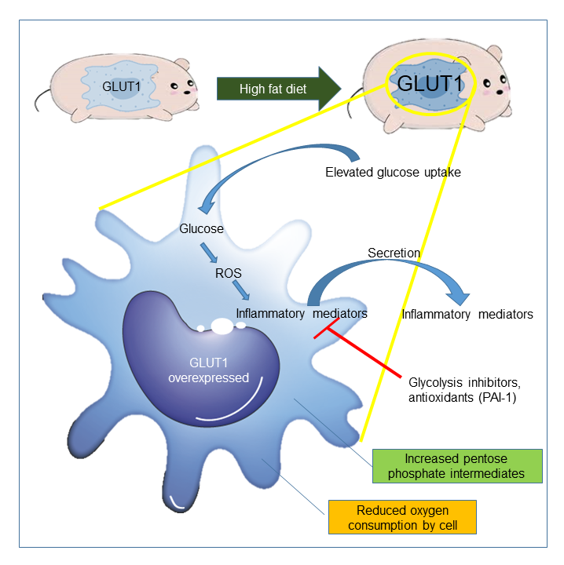

Summary
When rodents are fed with high fat diet, their macrophages are stained positively with GLUT1 thus representing its high expression. In this study, macrophages having genetically engineered to overexpressed GLUT1 showed an elevated cellular glucose uptake and reactive oxygen species (ROS) production which led to the increased production and release of inflammatory mediators from the macrophages thus leading to its pro-inflammatory morphology. Also, both the glycolysis inhibitors as well as antioxidants inhibit the production of these inflammatory mediators thus further emphasizing the inflammatory phenotype being mediated by the glucose and ROS pathways. In addition, an increased production of pentose phosphate pathway intermediates along with reduced cellular consumption of oxygen further confirmed the existence of oxidative stress under high GLUT1 expression.

