Electrical and Electronic Fundamentals

[Name of Student]

[Name of Institute]

**Task 1**

Part (a)

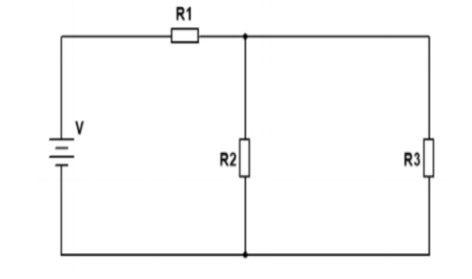

V = 12 V

R1 = 2.2 kΩ

R2 = 1 kΩ,

R3 = 3.3 kΩ,

Solution:-

a):- Applying KCL law:

I1 = I2 + I3 ----------------- eq 1

b) Applying KVL law:

Loop 1: V1 + V2– 12 = 0-------------- eq 2

Loop 2: V3 – V2 = 0 ---------------- eq 3

Applying Ohm’s Law:

V1 = I1 *R1

V2 = I2 *R2

V3 = I3 *R3

For Current:

From eq 3

V3 = V2

I3R3 = I2R2

By putting the value of R2 and R3

3.3 103 I3 = 1 103 I2

I2 = 3.3 I3

By using equation 1,

I1 = I2 + I3

I1 = 3.3 I3 + I3

I1 = 4.3 I3

By using equation 2,

V1 + V2 – 12 = 0

I1 R1 + I2 R2 – 12 = 0

ii. The currents in R1, R2, and, R3

We know that,

I1 = 4.3I3

I2 = 3.3 I3

R1 = 2.2 kΩ

R2 = 1 kΩ,

Hence,

[4.3 I3] [2.2 103] + [3.3 I3] [1 103] – 12 = 0

9640 I3 + 3300 I3 - 12 = 0

12760 I3– 12 = 0

I3 = 12 / 12760

**I3 = 9.404 10-4 A**

We know that,

I1 = I3

Hence,

I1 = 39.404 10-4

**I1 = 2.821 10-3 A**

We know that.

I2 = 3.3I3

Hence,

I2 = [3.3] [9.404 10-4]

**I2 = 3.10332 10-3 A**

The voltage across R1, R2, and, R3

For the R1

V1 = I1 R1

V1 = [2.821 10-3] [2.2 103]

**V1 = 6.2066 V**

For the R2

V2= I2R2

V2 = [3.10332 10-3] [1 103]

**V2 = 3.10332 V**

For the R3

V3 = I3 R3

V3 = [9.404 10-4] [3.3 103]

**V3 = 3.10332 V**

iii. The total power dissipated in the circuit

P= V I1

P = [12] [2.821 10-3]

**P = 0.0338 W**

**(b).**

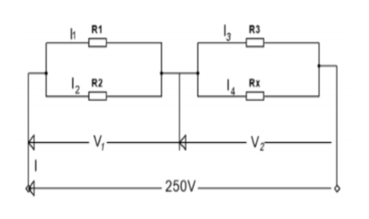

R1 = 15 Ω

R2 = 10 Ω,

R3 = 38 Ω,

P = 3.5 Kw

RX=?

I1=?

I2=?

I3 =?

I4 =?

**Solution:-**

PT= V IT

2.5 103 = 250 IT

IT= 2.5 103/ 250

**IT= 10 A**

PT= V V / Req

PT= V2 / Req

Req= [250]2 / 2.5 103

**Req= 25 Ω**

R1 an R2 are in parallel in a circuit

1 / R4 = 1 / R1 + 1 / R2

1 / R4 = 1 / 15 + 1 / 10

1 / R4 = 1/6

**R4 = 6 Ω**

Req= R4 + {(R3 RX)/ (R3 + RX)}

25 = 6 + {(38RX)/ (38+ RX)}

**Rx= 3.556 Ω**

R3 an Rx are in parallel in a circuit

1 / R5 = 1 / R3 + 1 / Rx

1 / R5 = 1 / 38 + 1 / 3.556

1 / R5 = 1 / 3.25

**R5 = 3.25 Ω**

For the V1,

V1= ITR4

V1 = 10 6

**V1 = 60 V**

For the V2,

V2 = ITR5

V2 = 10 3.25

**V2 = 32.5 V**

As in the parallel circuit voltage remain same.

V1 = 60

R1 = 15 Ω

R2 = 10 Ω,

For the I1,

V = I1 R1

60 = I1 15

I1 = 60 / 15

**I1 = 4 A**

For the I2,

V = I2 R2

60 = I2 10

I2 = 60 / 10

**I2 = 6 A**

We know that,

V2 = 32.5 V

R1 = 38 Ω

R2 = 3.556 Ω,

For the I3

V2 = I3 R3

32.5 = I3 38

**I3 = 0.855 A**

For the I4

V2 = I4 RX

32.5 = I4 3.556

**I4 = 9.139 A**

**(c).**

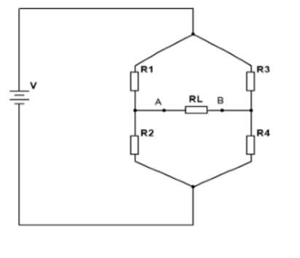

R1 = 40 Ω

R2 = 60Ω,

R3 = 60 Ω

R4 = 30 Ω,

RL = 20 Ω

**(d).**

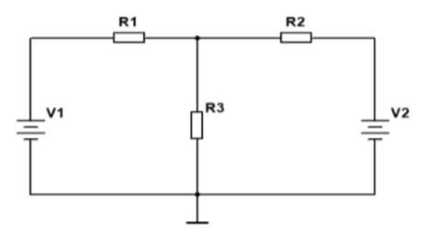

R1 = 12 Ω

R2 = 3 Ω,

R3 = [6] Ω

V1 = 84 V

V2 = 21 V

**Step 1:**

We know thatR2, and R3 are parallel,

1 / R4 = 1 / R2 + 1 / R3

1 / R4 = 1 / 3 + 1 / 6

1 / R4 = 1 / 2

**R4 = 2 Ω**

IT = VT / RT

IT = 84 /14

**IT = 6 A**

By, the CDR

[I1] = [6] * [3 / [3 + 6]]

**I1 = 2 A**

Considering (21v) voltage source,

AsR1, and R3 are parallel,

1 / R5 = 1 / R1 + 1 / R3

1 / R5= 1 / 12 + 1 / 6

1 / R5 = 1 / 4

**R5= 4 Ω**

As theR2, and R5 are in series,

R6 = R2 + R5

R6 = 3 + 4

**R6 = 7 Ω**

IT = VT / RT

IT = 21 / 7

**IT = 3 A**

By the CDR:

[I4] = [3] [12 / 12 + 6]

**I4 = 2 A**

Step 3:

I = I1 + I2

I = 2 + 2

**I = 4 A**

**TASK 2**

**(a)**

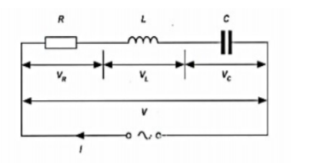]

**i. Voltage Drop across the resistor**

Vr = I x R

40 x 10-3 x 200

**Vr = 8 V**

**ii. Voltage drops across inductor**

VL= I x XL

XL= 2 x 𝛱 x f x L

XL= 2 x 3.14 x 50 x 80 x 10-3

VL= 25.12 Ω

VL= 40 **x** 10-3 **x** 25.12 V

**VL= 1.0048 V**

**iii. Voltage drops across capacitor**

Vc = Ic

Xc = 1 / 2 ℿ f C

Xc = 144.75 Ω

Vc= 40 x 10-3 x 144.75

**Vc = 5.79 V**

**iv. Impedance:**

Z={√[(R2)]}

Z= {(Xc – XL)2}

**Z = 135.3 Ω**

**v. Supply Voltage:**

Vs = I x Z

Vs = 40 x 10-3 x 135

**Vs = 5.4 V**

**vi. Current in the circuit:**

Current passing through the RLC circuit will remain same.

**I = 40 – mA**

**vii. Phase angle**

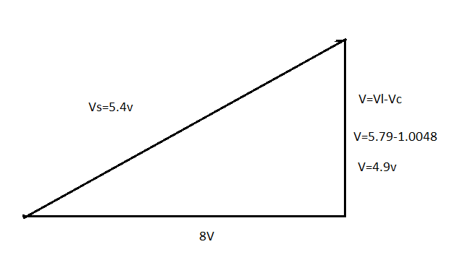

Angle of the 90 degree & voltage are reason able for lag in the capacitor so voltage is donated by V & Current in Ampere and Resistance in ohm in phase angle.

**Part (b)**

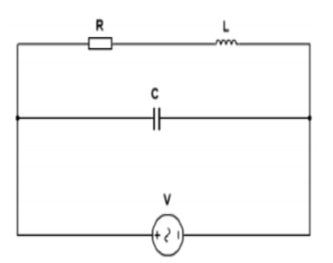

R = 3 k Ω

L = 0.12 H

V = 40 V

F= 5 kHz

**Solution:-**

1. **The current in the coil**

According to the Kirchhoff’s law:

I = I1 + I2

I = V / R + [V / jwL] + [V * jwC]

I = [40 / 3 x 103] + [40 / 2 * 5 x 103] + [40 * 2 * 5 x 103]

**I = 1.25 x 106 A**

**ii. The current in the capacitor.**

V = I*jwC

I = V / jwC

I = 40 / 2 * 3.14 * 5 * 0.02 $×$ 10-6

**I = 63.7 mA**

**iii. The Q-Factor**

φ= tan-1 *XL / R

Φ = tan-1 (2fL / R)

Φ = tan-1 ( / 1)

Φ = tan-1 (0.75)

**Φ = 36.86O**

**iv. The circuit impedance**

Z = ZR + ZL + Zc

Z= {$\sqrt{[(R^{2}) +{\left(X_{L}-X_{C}\right)}^{2}]}\}$

So,

XL = 2 $π$ fL

XC = 1 / 2 $π$ fC

Z = { $\sqrt{[({3×{10}^{3})}^{2} +{\left(2π ×5×0.12-1/2π ×5×0.02×{10}^{-6}\right)}^{2}]}$}

**Z = 3 KΩ**

**v. The power consumed**

[P] = [VI Cos φ]

P = [40] [63.7 x 10-3] Cos 36.86

**P = 2 W**

**(c)**

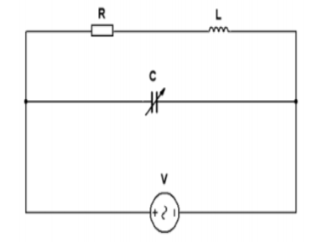

R = 1 k Ω

L = 0.12 H

V = 2 V

f = 10 kHz

**Solution,**

**i.**

V = IR

I = V / R

I = 2 / 1 x 103

**I = 2 x 10-3 A**

**ii.**

XC = V / I

XC =2/ 2 x 10-3

Xc = 1 x 10-3

XC = 1 / 2 $π$ fC

1 x 10-3 = 1 / 2 $π$ 10 x 103 C

**C = 0.015 F**

**iii.**

Z = ZR +ZL ]+ Zc

Z= {$\sqrt{\left[\left(R^{2}\right)+{\left(X_{L}-X_{C}\right)}^{2}\right]} \}$

Therefore,

XL = 2 $π$ fL

XC = 1 / 2 $π$ fC

Z = { $\sqrt{[({1×{10}^{3})}^{2} +{\left(2π ×5×0.12-1/2π ×5×0.015\right)}^{2}]}$}

**Z= 1 K**

**iv. The Q-factor**

Q = 1/R] [$\sqrt{L/C}$

Q = 1 / $1×{10}^{3}$] [ $\sqrt{0.12/0.015}$}

**Q = 2.8510-3**

**v. The bandwidth**

w = 2 $π$ f

B.W = [w] / [Q]

B.W = [2 $π$ (50)] / [2.85 $×$ 10-3

**B.W = 110 KHz**

**vi. The current in each branch**

I1= IR + IL

IR = V / R

IR= 2 / 1103

**IR= 2 10-3 A**

IL =V / L

IL = 2 / 0.12

**IL = 16.67 A**

I1 = 210-3 + 16.67

Current in branch 1:

**I1= 16.67 A**

**branch II Current:**

I2 = V/C

I2 = 2 / 0.015

**I2 = 133.3 A**

**v. Supply current**

IT= I1 +I2

IT = 16.67+ 133.3

**IT = 150A**

**Task3**

**Part (a)**

**“Diode’’**

Diode is the electronic device which can block all current flowing the reverse direction and it’s behave like as a short circuit and its behaviour in the forward region is quite ideal

It can consume power when it conducting forward current and it more complicated and have a unique characteristics between Voltage and Current.

**Current-Voltage Relationship**

The important diode characteristic is its current-voltage (i-v) relationship. In this way it easily define how much current running through a component is and also the given what voltage is measured across it. For example,

The V-I curve of a diode, though, is entirely non-linear. It looks something like this:

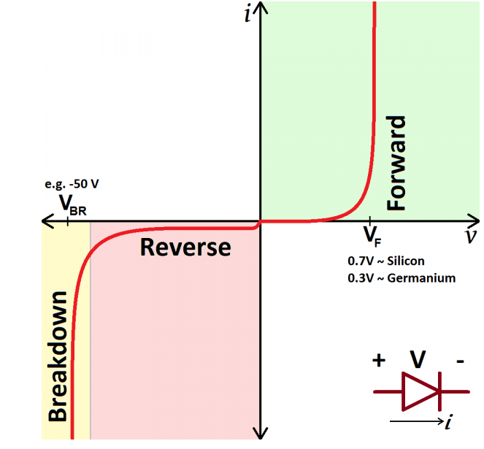

**Part (b)**

**1).**

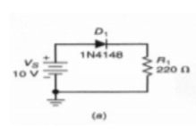

**Forward Bias**

**Table**

|  |  |  |
| --- | --- | --- |
| **Vs** | **Measured (V)** | **Measured (I)** |
| 0 | 0 | 0 |
| 1.5 | 0.05 | 0 |
| 1 | 1.09 | 0.04 |
| 2 | 2.87 | 0.64 |
| 3 | 4.83 | 5.01 |
| 6 | 5.63 | 8.8 |
| 8 | 6.29 | 20.24 |
| 10 | 6.47 | 23.3 |
| 15 | 6.85 | 28.7 |

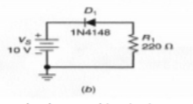

**Reverse Bias**

**Table 3.1**

|  |  |  |
| --- | --- | --- |
| **Vs** | **Measured (V)** | **Measured (I)** |
| -5 | 0.58 | 0.4 |
| -10 | 8 | 5.8 |
| -15 | 10 | 8.8 |

**2).**

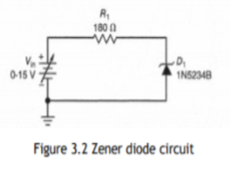

**Zener diode**

|  |  |
| --- | --- |
| **Vin** | **Vout** |
| 0 | 0.2 |
| 2 | 2.8 |
| 4 | 4.7 |
| 6 | 6.5 |
| 8 | 8.4 |
| 10 | 10.3 |
| 12 | 12.7 |
| 14 | 14.9 |

3).

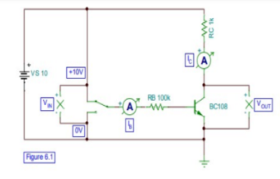

**Bipolar Transistor as a Switch**

|  |  |  |  |  |
| --- | --- | --- | --- | --- |
|  | **Vout**  **When Vin = 0** | **Vout**  **When Vin = 10** | **Ic**  **When Vin = 10** | **Ib**  **When Vin = 10** |
| Measurement | 110 | 120 | 0.01 | 110-4 |

Part (c)

Full wave bridge rectifier operation

In the positive half cycle of input voltage the upper end is positive and D1 and D3 are FW and current flow through point AB enter un load resistance. Return back through arm dc. During positive half cycle D2 And D4 are reverse base and current are flowed in AD and BC. (circuitstoday.com)

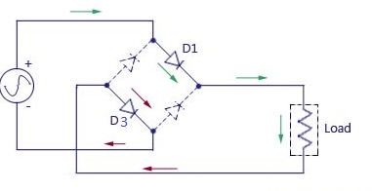

In the negative half cycle the lower end of transformer is positive and D2 and D4 is forward biased and current flow through CB and enter to the load and return to the source. (Brumme, et.al, 2015, p.155436)

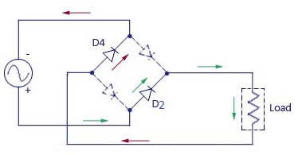

Zener diode are used as shunt regulator and voltage reference to regulate the voltage across the small circuit. When it connected with voltage it behave reverse biased. So in this way zener diode conducts when the voltage reaches the reverse diode break down voltage.

The transistor behave like a amplifier by increasing strength of week signal. The dc supply bias voltage is applied to the emitter base junction, it still remain in forward junction when transistor work as a amplifier.

**Part (d)**

BJTs and FETs are two different kinds of transistors and also known as active semiconductor devices. The acronym of the BJT is Bipolar Junction Transistor and FET stands for Field Effect Transistor. Both BJTS and FETs can be used as switches and amplifiers in electrical and electronics circuits. (Lanni. L, et.al, 2014, p.428-430)

**Task 4**

**Part (a)**

**Analogue Signal with Example**

The analogue signal is the continuous wave that change randomly on every point.it can representation by the sine wave. It can be describe by the amplitude and frequency. So in this way it have no range.

According to it example human voice, video and audio transmission and the signal come from microphone that is analogue signals.

**Digital Signal with Example**

The digital signal is a discrete wave that carry information in binary form and it can represented by square wave, it have finite number so it can carry data in binary form.

According to example digital signal use in computer for the signal transmission, in integrated circuit digital signal are used, interfaces of Serial Peripheral Interface and transmit all data via a coded sequence of square waves. (Oktyabrsky, et.al, 2010, pp. 163-165)

**Part (b)**

In the amplifier the gain is a measure for the "Amplification" of an amplifier, it depend on gain how increases the amplitude of the signal. That is obtain ratio of the output signal amplitude to the input signal amplitude, and it is denoted by symbol "A". It can be calculated for voltage (Av), current (Ai) or power (Ap), for the Voltage gain Av = Amplitude of output voltage ÷ Amplitude of input voltage And the Current gain Ai = Amplitude of output current ÷ Amplitude of input current and for the Power gain Ap = Signal power out ÷ Signal power in.

In the amplifier a piece of information that can be obtained from a frequency response curve is the Bandwidth of the amplifier. That can be refers to the ‘band’ of frequencies for which the amplifier has a useful gain and the input resistance of the amplifier should be zero and the output resistance should be infinite. (Oktyabrsky, et.al, 2010, pp. 163-165)

**Part (c)**

|  |  |  |  |
| --- | --- | --- | --- |
| **Input 1** | **Input 2** | **Out Put** | **Function** |
| 1 | 1 | 0 | NOR |
| 0 | 0 | 1 | NOR |
| 1 | 0 | 0 | NOR |
| 0 | 1 | 0 | NOR |

**Part (d)**

These are the logic gates and in this logic five NOR gates used so it is NAND gate . (Nategh, S., 2013).

**Part (e)**

The benefits of digital signals, including digital signal processing (DSP) and communication systems, include the following:

The noise, distortion, and interference of the digital signal is less and it reproduce in mass quantities at low cost. That system is more flexible due to (DSP) operation .digital signal processing is more secure because can be easily encrypted and compressed. It can more accurate and error probability can be reduce by employing error detection and correction codes. It can easily store in any magnetic media and transmitted over long distance.

The benefit of using analogue signals, including analogue signal processing (ASP) and communication systems, include the following:

Analogue signals are easier to process and suited for video and audio transmission. They have much high density and have refined information. It have les bandwidth than digital signals and it have more accurate representation of charges in physical phenomena like temperature, position and pressure. Analogue system are less sensitive in term of tolerance. (Brumme, et.al, 2015, p.155436)

**Part (f)**

The use of analogy signal d audio transmission and the signal come from microphone that is analogue signals. The [composite video](https://en.wikipedia.org/wiki/Composite_video) coming out of an old RCA jack. Tiny changes in the signal have a huge effect on the colour or location of the video. (Nategh. S, 2013)

Digital audio is a representation of [sound](https://en.wikipedia.org/wiki/Sound) recorded in, or converted into, [digital form](https://en.wikipedia.org/wiki/Digital_signal_(signal_processing)) and Digital audio can be stored on a variety of storage media, including compact disc, audio CD, audio DVD, DAT tape, or as a computer file.

**Reference**

* Brumme, T., Calandra, M. and Mauri, F., 2015. First-principles theory of field-effect doping in transition-metal dichalcogenides: Structural properties, electronic structure, Hall coefficient, and electrical conductivity. Physical Review B, 91(15), p.155436.
* Lanni, L., Malm, B.G., Östling, M. and Zetterling, C.M., 2014. Lateral pnp transistors and complementary SiC bipolar technology. IEEE Electron Device Letters, 35(4), pp.428-430.
* Nategh, S., 2013. Thermal analysis and management of high-performance electrical machines (Doctoral dissertation, KTH Royal Institute of Technology).
* Oktyabrsky, S. and Peide, D.Y. eds., 2010. Fundamentals of III-V semiconductor MOSFETs (pp. 163-165). New York: Springer.
* https://techdifferences.com/difference-between-analog-and-digital-signal.html
* https://learn.sparkfun.com/tutorials/analog-vs-digital/all
* SparkFun Electronics ® 6333 Dry Creek Parkway, Niwot, Colorado 80503
* https://learn.sparkfun.com/tutorials/diodes/all
* <https://www.circuitstoday.com/>