**CONSTRUCTION TECHNOLOGY**

{Name of Writer}

{Name of Institute}

{Date}

Contents

Introduction 3

Task 1(LO1) 4

P1 4

P2 7

P3 9

Task 2(LO2) 11

P4 11

P5 13

Task 3(LO3) 18

P6 18

P7 20

Task 4(LO4) 18

P8 21

P9 22

Conclusion 24

References 25

**Introduction**

The study of the civil construction is consist of design and development of new and the latest trend of structure.

The material that can purchase for the construction of the building or the house after the completion of the project than it can return to the costumer.

The business person of construction is design on the hotel complex through the new thought and the situations and that is near to the highway that connect to uk international airport.

There is distance between the hotel and the broad river which lead to Thames River. So the range of the visitor is approximate 200 peoples in which they can stay easily in the hotel. The material is used in the hotel construction is incorporating steel and concrete.

The basic structure path is stiff and robust, together with steel or an RC concrete road as well as bridge over the highway.

This study would thus clarify the terms as well as the structural and technical criteria for the standard design building of the hotel. The super as well as substructure of hotel complex should be complemented by those interested in building development.

**LO1**

**Task (1)**

**P1:- Describe the different between residential, commercial and industrial buildings?**

The main difference between the three types of buildings is given as follows

* **Residential Building**
* In this type of construction no need of high equipment or machines for residential buildings. But for the working need for the specialized team of member for the construction.
* The main factor of that type of the building is construction on the wood or concrete where mind can be adjust.
* These type of the building has multiple number of the ways of options to pick the best building material which use in the construction.
* Mostly in this type mostly constructed and the residential structures, in which people work and selection of area for live, so in this way including the houses, apartments of room and other residences are consist in this part.
* In these type of building the responsible on occupant and the landlord for constructing residential buildings.
* These types of Residential structures are consist of the property, city house, condominium and the residence, the, etc.
* **Commercial Building**
* In this types of building that consists of a large number of house the construction of a building property consist on both in small or even bigger as well as larger.
* For the commercial construction of the building the high machinery is required as well as also need of the crane equipment is for commercial construction purposes.
* In the Commercial buildings the main structure is based on steel structure and quality of steel is select can be affordable related to the project.
* These Buildings are construction for long term so maintain its maintenance for the long stability.
* The commercial construction shall use to build the house for offices or companies, school, banks, Business decisions office have been taken for prohibit industrial construction.
* In this way apartment houses, stores, medical centers, Malls, hotels, farm lands are consist of all commercial buildings.
* **Industrial Buildings**
* Standard construction machinery, including cherry pickers, breakers, cranes, bituminous mixtures, etc., shall be mandatory for construction of industrial buildings.
* Industrial structures rely primarily on concrete even as major panels consist of concrete as well as the boxes contain thin sheet of steel (Blanco, et.al. 2017).
* Modern facilities shall be built for the manufacture of goods and services such as power stations, factories, laboratories, gas stations, etc.
* Industrial constructions involve industrial parks, science & development parks, mills, power stations, gas power station, etc.

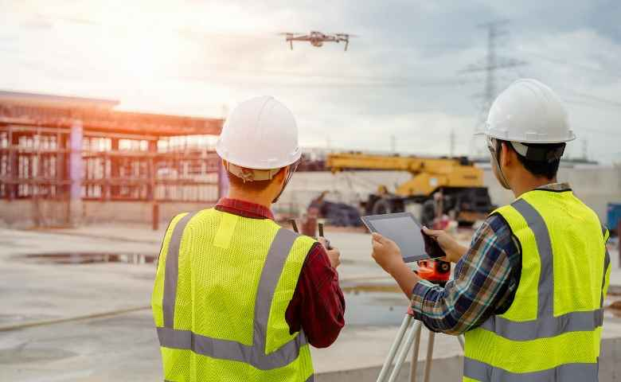

Figure 1: : Technologies used in construction

Thus the main vision of the designer related to the building construction that he will design the housing development with the unique and with engineering technique. So these types of the structure are the consist of the commercial purpose so these types of hotel is utilize the hotel in the commercial purpose of the hotel and availability of 200 vister of residence facilities according to their needs.

(Blanco, Mullin, Pandya, and Sridhar, 2017.).

**P2:- Explain how the functional characteristics and design selection criteria and informed by proposed building use.**

In this part describe the functional and the design section for the building construction.so the construction of the whole hotel building is complex in the construction so in this way different steps should be taken for the designing of the hotel building and then follow the different factor to create the best profit of the commercial building for obtain high performance.

* Create the proper budget-balance, protection and security, expense, for environmental architecture for obtain the good work.
* Before the starting construction budget should be managed to clear that no problem create at the construction time.
* That should be Superior as well as better indoor air quality depending on all room specifications.
* Efficient energy efficiency and structural construction.
* The owner person should build hotel in just that way that utilize of greenhouse gas emissions can be minimized and it will be create a green free environment.
* The light lux should be maintain for the best acoustics as well as lighting must be within the house.
* The building built shall have it also consist of thermal comfort and sufficient noise moisture levels.
* The strategy of the designing

The design of any construction is depend on the previous Performa in which randomly changes for the improvement of the construction work. In this way easily define the expense of the building work and its property cost (Blanco, et.al. 2017).

This type of the previous Performa can sure the expense of the market cost and also verified the builder charges so after than give the tender to the construction of the new hotel building.

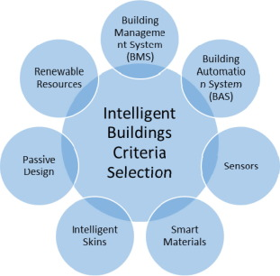

Figure 2: Intelligent Building Criteria Selection

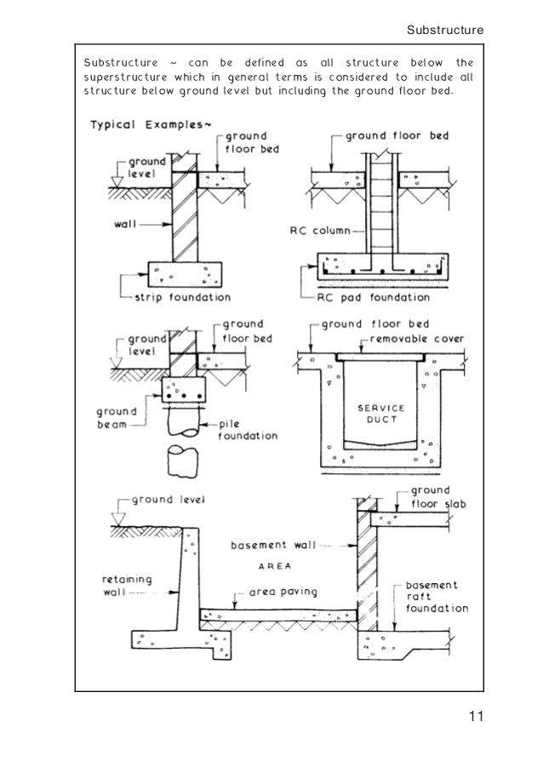

Figure 3: Technical Design Report for Selection Criteria of Buildings

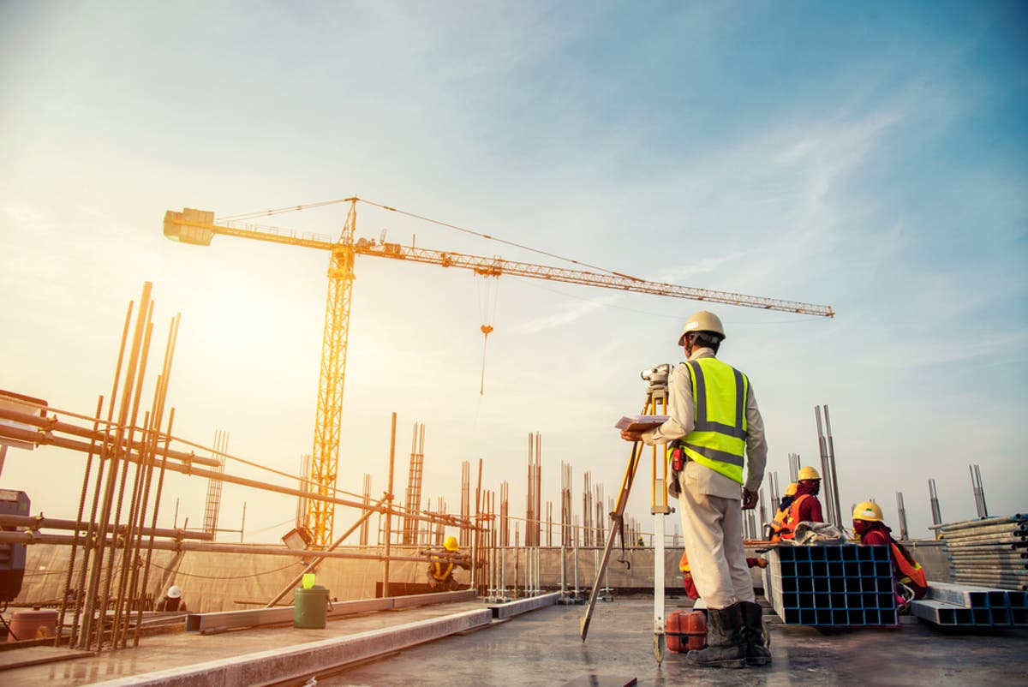

Figure 4: Construction is using advanced technologies

Budget is not the main reason after the funding it can be allocated as well as it can explained on the soft wear for the planning of the work. The concept and experience in the main thing to describe the target of the construction of the building.

This does not include drawings as well as construction of the buildings but rather a notion what the owner would need for a parking area, what stuff they would like to incorporate, So also see the achievement of the goals in which project or building going on. So in which everything is mention related to the structure in the reports. How it feels and how it can conform to all specifications.

According to the acceptance of the design the local government can give the approval to design of the construction and designer can give the design for the approval of the project.

One have quite enough information about building from Curriculum and Pro Forma so that you can inform the designer and take approval from government that is called the Entitlement. With the authorities, one must verify that this structure would together with certain amenities be built in this area (Martin and Perry, 2019).

Perhaps the council will add new features as well as take less car park space and maybe they will also want one to do more for public, like build a little park for young and elderly ones for the daily walk. They may also limit one to comply with the laws which parking could not be too comprehensive.

Finally, after all of this the allowable plans would demonstrate how the structure will be built. All must be submitted, including construction permit proposals, expense projections and building activity scheduling plans. This is the method and standards whereby commercial building will be built as a hotel housing complex.

**P3:- Discuss the ways in which sustainability can be promoted in building projects.**

The developed building should design In the range of the effective budget, so main thing the design of the whole hotel in the stable condition so the technique is used for the apartment and the control of the energy conservation and also use the comprehensive approach by tackling environmental concerns including waste control, water management and the choice of sustainable materials

In any step of a strategy process of development, maintain the architecture design that has a wealth of advantages to improved wellbeing due to cleaner fabrics, improved efficiency due to a healthier atmosphere and better safety from noise are just some of the benefits. The green buildings will enhance the quality of life.

( Radziszewska-Zielina, Kania and Śladowski, 2018).

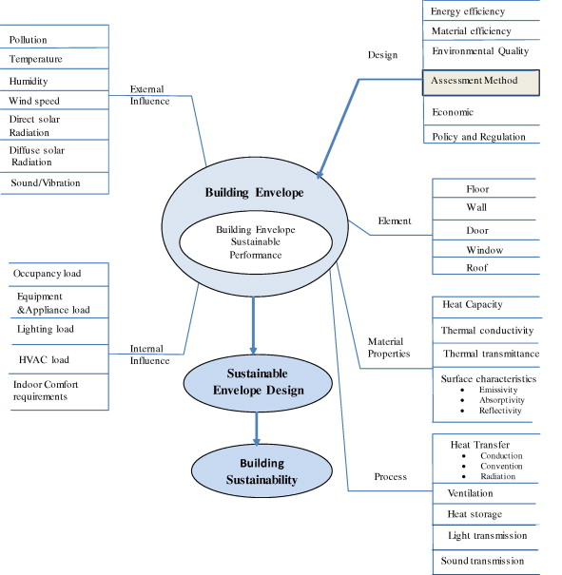

Figure 5: Sustainable construction

The construction should be designed in the stability condition that can obtain in various forms. The following design and main factor are described below:

* **Storage of the rain water –**

By the storing rainwater, that storage water use in the bathroom than flow to the savage system that method should minimizing the usage of essential water as well as reduce the possibility of floods. The person who pumps water to building often has the ability to conserve energy.

* **Use passive cooling Technique –**

I this technique it can depend on the designing of the construction of the building reduce the heat from the home and for the cooling environment so for heating and cooling through utilizing materials that have strong thermal mass characteristics only to conserve energy.

* **Accurate Lighting intensity –**

It must be accurate in all the room for the proper work in the room if it not ok than cause the hazard so that Is not good so design of the construction is select into consideration that minimal lighting ought to be available, the detectors as well as bulbs must be mounted and natural daylight should be used more throughout the day.

* **Clean Energies Sources –**

In this way Renewable energy can be used for the electricity that can help reduce greenhouse gas when we not use the generator so gas can create the carbon dioxide fascination. Wind turbines and photovoltaic are the application of the clean renewable resources of the energy.

* **Green roofs –**

In this way uses of the trees around the houses also the shade of the plant trees into the roof so can minimize the consumption of greenhouse gas cause the removing of CO2, so it can supplying occupants with an enticing and beautiful climate.

* **Availability of Electrical technology –**

The monitoring of heating, power and air conditioning would save a lot of energy, thereby demonstrating how often energy is used throughout the building wherein residents know about electronic technology, like screens. So it is good use of renewable energy resources.

**(LO2)**

**Task (2)**

**P4:-Describe the pre-design studies carried out and types of information collected for a given construction site.**

Pre design is the initial stage like the primary stage of the analysis in which see the budget before starting the construction. Before start in construction the analysis of the work Place where the work be done and see the how space need for the construction.

(Cho, et.al. 2018).

The funds of the budget can see throughout this process will only be made availability for the discovery and analysis of technological challenges to finish the whole building project of a hotel as well as to review the project's schedule, timeline and scope.

The pre-design processes primarily include the cost of constructing, site review and value engineering, programming.

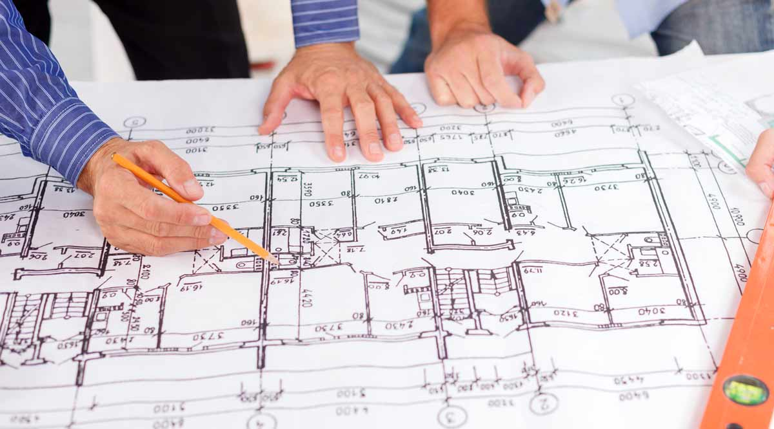

Figure 6: Pre-design phase in construction

* This process Programming shall explain the required machinery and equipment for the starting of this project.
* First of all contractors shall analyze the cost budget analysis required needed for the building, and after that project manager shall provide this guide in order that budget could be accurately measured.
* The site selection, project budget and as well as program analysis will be found throughout the value engineering.
* The primary pre scribe is depended on the site review for the selection of the site and the geotechnical reports to display the recent findings.

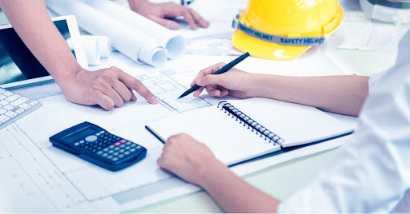

Figure 7: Pre-design phase in construction

The designer person prepare and apply the level of construction of the whole complex hotel (Chew, 2017).

The explanation is the simple way that can be supplied to the contractor contractors and the designers, and the other required person

. The following are main points of details to be submitted throughout time of building: –

* Explanation of the project should be in the detail in which mention that when the project will launch and what is its time duration of completion
* Secondly the more detail is relevant to construction management and project design, how the development will take place and also how many spaces are necessary,
* Even where the entrance point of the hotel and how it will take place and when so many extra planning sections are needed together with successful construction project management.
* The health & security details that is really important to the people constructing the hotel.
* Everybody should mindful of the protection them self, as this seems to be very dangerous if any of these materials fall on a certain contractor.

**P5:- Explain the functional characteristics and design criteria for primary and secondary elements of a building substructure and superstructure.**

Primary Elements are the components of the building that above the substructure and excluding secondary services, fittings, elements and finishes.

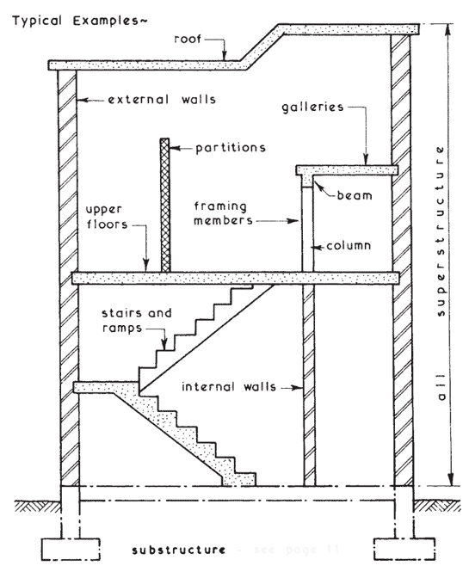

Figure 8: Superstructure and primary element

Secondary Elements are completion of the base structure in which including completion around and within the openings in primary elements.

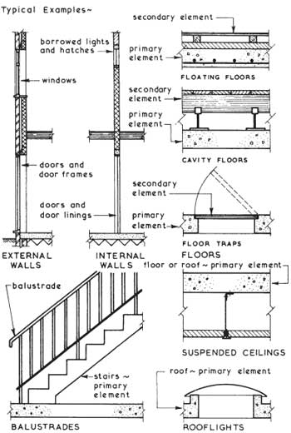

Figure 9: Superstructure and Secondary element

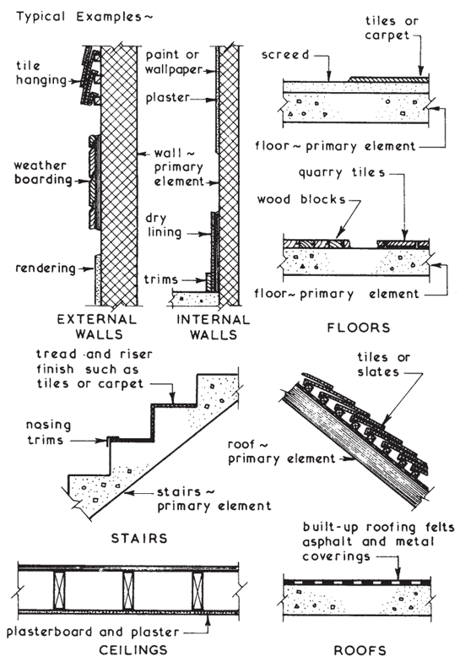

Figure 10: Superstructure and Secondary element example

Finish is the final surface in which it can be self-finished with applied finish such as floor tiles or the trowelled concrete surface.

* Substructure is the lower stage structure in which comprises the basement as well as the foundation. This describes the lower section of building which bears the weight of the whole building (Feng and Shen, 2020).
* Superstructure is the framework in which forms the living portion of the inhabitants at above floor level. That's the greatest level at which the aim of living is to be used.

Difference between functional aspects of superstructure & substructure

* **Superstructure**
* Windows are built throughout the superstructure.
* Doors as well as pillars are conceptually built so everything is the perfect finish for the building.
* The substructure consists of Partitions, decks, columns, frames, windows and so on.
* Walls should be installed throughout a superstructure so the whole building is built.
* **Substructure**
* Throughout the ground floor with base ought to be established.
* Provides the building with resilience and the security.
* Floor should be designed to begin the structure first.
* It should covers the basis and the fineness.

**Strategy for the design**

Design requirements should be built so as to provide a place for the tenants to feel comfortable throughout the building in every hotel residential building.

The building needs to be equipped and clean. A building should have its main and secondary shops throughout the comfortable place. In order to ensure a stable and comfortable building, upkeep should be clearly established (Lou, Xu and Wang, 2017).

**(LO3)**

**Task 3**

**P6:- Describe techniques used for remediating the site prior to construction commencing**

Site repair is synonymous with the concept that indicates that even if a harm or destruction happens in a house, the solution to mitigate the damage would be established. Site restoration can involve soil regeneration, dilution of emissions, building project capping. In addition to the internal and external condition of a structure there are also strategies for problem - solving approach. The need for recovery of sites is extremely common because of small areas of property to be built. The urban ground which is polluted by the soil used to create a new building during the previous development (Wen, et.al. 2018).

With more weather requirements, the renovations will be improved by-day.

* **Preventing the expansion**

It is really a common method to contaminate surface and water throughout site, or even to divert water also soil from contaminated areas. Containment: The key goal of the enclosure is to achieve low-permeability also waterproof the cutoff walls. The majority of walls have been built as well as constructed from a combination of soil or water, and then it will harm inhabitants if soil that contains several toxic compounds is being used to pollute the soils. This will destroy the walls that were built; it is also very important to rehabilitate the site if such damage happens.

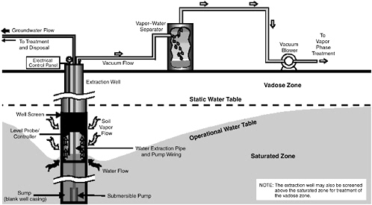

Figure 11: Remediation technique for construction

**Treat through the Pumping**

It is considered to be the primary form of surface or groundwater recovery on construction. This procedure pumps the water up to surface as well as then extracts the contaminated water by different methods containing ultraviolet, thermal decomposition, carbon activation, etc. By achieving more than a single pumping well, this technology becomes successful (Shrestha, 2018). The polluted water was extracted from site by this process. This method is very advantageous since it is often used throughout groundwater dissolving chemicals.

Some others are:

* Offer facilities for constructing complete maquillages of items like workstations, workshops, casework, building info, etc.
* Plan building phase - sequences, bid packing, easy monitoring and any other information.
* Supporting software specifications, including Proposal Request and Quote Requests (RFQ).
* The master budget, expense forecasts and the cost-to-full forecasts are created, retained and revised.
* Establish seamless information networks, contact channels, job assignments, project management strategies, comprehensive preparation.
* Help in development of furniture design services, moving appliances, fire/life protection signs and graphics, as well as other visual signage programs.
* Identify and assess appropriate hazardous material mitigation steps.

**P7:- Describe the types of substructure works carried out by civil engineers**

Civil Engineer Carried different types of substructure and that can execute during the construction of

the house or the building which are following:-

* **Supporting part of strip**

It is the design in which it can easily bear the pressure of the building so it have multiple layer as well

as it can obtain strain wide of walls and it have ability of strong grip to the base of the building.

* **Mat and Raft supporting part**

This substructure are in use to construct cellars, which can carry the weight of the whole house. This segment is mostly said of a canoe, since it have been shaped as a boat and floats throughout the sea of the soil. In the other side, Matt is the framework used where the building's soil becomes so fragile and the soil cannot withstand the weight and all columns and so it can be structured in a manner that it can contact and stay closed.

* **Separate structure**

It is a basic substructure utilized mostly for the control and loading or mass of the built environment by arrangement and layout of column. This is built for the utilization of concrete at any stage of building

(Lingard and Wakefield, 2019).

* **Shallow structure**

This is substructure called an open as well as distributed substructure by another word. This concept is adequate to clarify that shallow sub-structure is being used primarily for constructing and designing open environment throughout the upper portion of structures. This segment is only ever developed at the beginning. The work completed under such a substructure will not be demonstrated after whole project has been constructed.

**(LO4)**

**Task (4)**

**P8:- Describe the supply arrangements for primary services**

Building are design to build the user and the feel free for any one so these types of the main services are called the development services.

So the primary facilities of the building are such services of the construction in which show the building in the clean construction. So in which every body want to live in the area so it stable and pleasant to live that’s due to the hardworking of the constructor and the main mechanism for the primary facilities are the listed in steps.(Kim, et.al. 2017).

* **Location of lifts or Escalators –**

These types of the facilities should be availed in the present time for the old person or for every person due to it take less time for the travelling during one floor to maximum number to floor and it lifts will carry heavy baggage.

* **Energy Sources**

To run everything the electricity is the main source lights, lifts, tv plumbing, water, irrigation and all the home or building thing are depended on the electricity.

* **Ventilation and Heating path**

The room of the building or the room should be passive design so room must be also built for the Illumination to produce heating or air conditioning so that visitors remain cool.

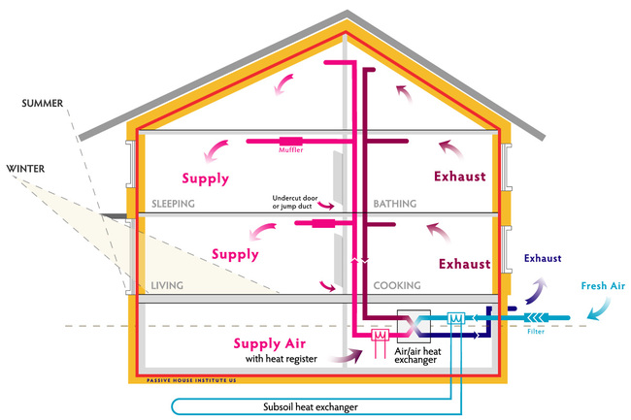

Figure 12: Heat and ventilation

Primary services still need to be divided into three properly organized sections that are extremely important for the development other such–

* **Electrical power Systems**

Electrical systems contain power components, such as electricity, auxiliary energy and electricity. These are all really important and are the requirements of any person visiting or staying in hotel.

* **Mechanical equipment**

This scheme specifically includes irrigation areas, HVAC systems, piping, gas supply and fire safety systems, etc. Much of this is tied to building's protection along with people who work throughout the construction complex of hotel.

* **Operating Systems of Building**

This covers the amenities that are important for supplying the customers such as escalators, skyscrapers, parking facilities, lifts etc. Production is also used throughout the food as well as product services, automatic parking or lighting systems, as well as automating systems.

**P9:- Explain the distribution arrangement for primary services**

The delivery arrangements services consist of construction of loops that is called the distributor feeders. So the primary services can divide in to few phase for the delivery arrangements and that known as principle feeders same like as the four wire network system.

Single and three phase circuit is related to the primary services of the distribution arrangement. so the both circuit is related to the primary feeders, so that is consider as the basic level of the feeder.

The high power supply from primary to secondary and that can travel in the both circuits. So 3- phase circuit can also used as the 4 wire system, so it application devices are interconnected in the star connection because in the four wire system so these connection used in every buldings, (Sereda, 2019).

The delivery arrangements largely minimize the reach of the primary circuit as well as accomplish facilities via electric power loss. At the same time as building every company the key purpose of the delivery arrangement throughout the primary utilities is to gather power as well as supply everything to lighting, elevator, electricity generators, etc.

**Conclusion**

From this report the conclusion can be obtain that latest technology will improve the cooperation and productively of the building industries.

Latest technology can improve and increases the quality of the performance on any project Construction Technology is consist on the selection, of advanced equipment, machines, during construction stage, enhancements and software, etc.,

So in this way it make improvement throughout the field building techniques, such as semi-automated as well as automated constructive devices. The study of construction technology should be all about building an environment where individual feels secure and happy to live or remain peacefully.

In the sense of the hotel building design in which hotel owners want to manage 200 people, the above-mentioned report was created.

Abovementioned reports explain the whole definition of the construction technology and identify the requisite details before constructing the hotel building. In addition, there is a specification of sub-structure including primary resources. Sustainability and the comparison between different building styles have been established.

* **References**
* <http://www.buildersengineer.info/>
* Blanco, J.L., Mullin, A., Pandya, K. and Sridhar, M., 2017. The new age of engineering and construction technology. McKinsey & Company-Capital Projects & Infrastructure.

Chew, Y.L.M., 2017. Construction technology for tall buildings. World Scientific.

* Cho, H.P., Lim, H., Lee, D., Cho, H. and Kang, K.I., 2018. Patent analysis for forecasting promising technology in high-rise building construction. Technological Forecasting and Social Change, 128, pp.144-153.
* Feng, Z. and Shen, Y., 2020, March. Discussion on construction technology of deep foundation pit support in construction engineering. In IOP Conference Series: Materials Science and Engineering (Vol. 787, No. 1, p. 012038). IOP Publishing.
* Kim, P., Bang, S., Kim, K. and Kim, H., 2017. Research of actual condition and mitigation plan for aging workers' health and safety at construction sites. Korean Journal of Construction Engineering and Management, 18(1), pp.37-47.
* Lingard, H. and Wakefield, R.R., 2019. Integrating work health and safety into construction project management. Wiley-Blackwel
* Lou, J., Xu, J. and Wang, K., 2017. Study on construction quality control of urban complex project based on BIM. Procedia engineering, 174, pp.668-676.
* Martin, L. and Perry, F., 2019. Sustainable construction technology adoption. In Sustainable construction technologies (pp. 299-316). Butterworth-Heinemann.
* Radziszewska-Zielina, E., Kania, E. and Śladowski, G., 2018. Problems of the selection of construction technology for structures in the centres of urban agglomerations. Archives of Civil Engineering, 64(1), pp.55-71.
* Sereda, T.G., 2019, August. Evaluation of background content of priority contaminating substances in atmospheric air at the pre-design stage of construction of landfill solid waste disposal. In IOP Conference Series: Earth and Environmental Science (Vol. 315, No. 5, p. 052007). IOP Publishing