**LO1**

**Part (1)**

According to law of sine’s

$$\frac{a}{sinA}=\frac{b}{sinB}=\frac{c}{sinC}$$

Take any two sides

$$\frac{a}{sinA}=\frac{b}{sinB}$$

$$b=a*\frac{sinB}{SinA}$$

$$=a*\frac{sin61°}{sin53°}$$

$$b=13.79$$

**Part (b)**

$$a→\frac{8}{17} it is sine=\frac{ρ}{H}$$

$$b→\frac{15}{17} it is sine=\frac{B}{H}$$

Where

$ρ$ = perpendicular

B = Base

H = Hypotenuse

**Task (2)**

**Part (a)**

$$y=4 cos (20+45)$$

$$y=4 cos \left(20+\frac{π}{4}\right)$$

1). Amplitude (A) = 4

2). Period (P) = $π$

$$y=4 cos \left(20+\frac{π}{4}\right)$$

Amplitude = 4

Period = $180°$

$$\frac{waveform}{curve between} 0 → 360°$$

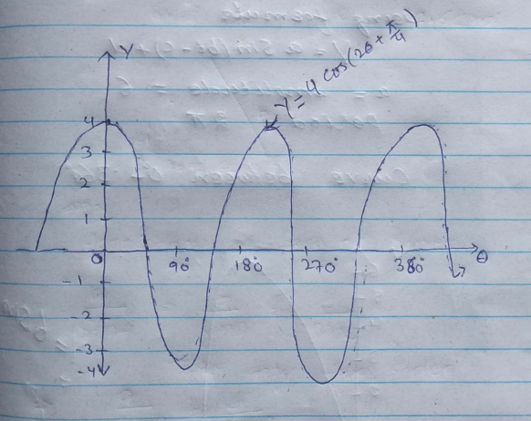

**Part (b)**

Using formula

$$y = asin (bt-c)+d$$

a = amplitude = 6

Period = $2π$

$$curve between 0° to 360°$$

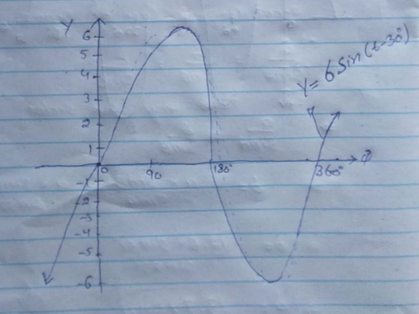

**Part (c)**

Taking LHS

$$sin⁡^2x*\frac{secx+cosecx}{cosx tanx}$$

$$\frac{\left(\sin^{2}{x}*secx \right) +\sin^{2}{*} Cosecx}{cosx *\frac{sinx}{cosX}}$$

$$\frac{〖\left(\sin^{2}{x}*secx\right)+\left(\sin^{2}{x}*cosecx \right)]}{\left(sinx\right)}$$

$$\frac{〖\left(\sin^{2}{*} secx\right)+\left(sinx*sinx*cosecx\right)]}{sinx }$$

$$\frac{\sin^{2}{*}secx}{sinx}+\frac{sinx}{sinx}$$

$$\frac{\sin^{2}{*}secx}{sinx}+\frac{sinx}{sinx}$$

$$=sinx*secx+1$$

$$1+\frac{sinx}{cosx}$$

$$=1+tanx Proved$$

**LO2**

Part (1)

a).

Trapezium Rule A/C to the formula

Area = d/2[(o1+o7)+2(o2+o3+o4+o5+o6)]

Area= 25/2[(3.6+4)+2(5+6.5+7.5+7.3+6)]

Area= 25/2[7.6+64.6]

Area902.5 sqm

b).

Simpson’s Rule

According to the formula

Area= d/3[(o1+o7)+4(o2+o4+o6)+2(o3+o5)]

Area= 25/3[(3.6+4)+4(5+7.5+6)+2(6.5+7.3)]

Area= 25/3[(7.6)+4(18.5)+2(13.8)]

Area= 25/3[7.6+74+27.6]

Area=910 sqm

c).

Mid ordinate Rule

Accourding to the formula

Area= (sum of all ordinates*L) / n

Where L= n*d (L= length of base line)

Area= [(o1+o2+o3+o4+o5+o6+o7)*L]/ 7

L= n*d

L=7*25

=175m

Area = [(3.6+5+6.5+7.5+7.3+6+4)*175]/7

Area=999.5 sqm

Compare and Comment

|  |  |  |
| --- | --- | --- |
| Rule | Area | Comment |
| Trapezium | 902.5 | Less accuracy |
| Simpson’s | 910 | High Accuracy |
| Mid Ordinate | 997.5 | accuracy |

Part (2)

$${2log}_{9}\left(√x\right)-\log_{9}\left(6x-1\right)=0$$

$${2log}_{9}\left(√x\right)=\log_{9}\left(6x-1\right)$$

Simplify ${2log}_{9}\left(√x\right)$ by moving 2 inside the logarithm

For the equation to be equal, the argument of log must be equal

Therefore

$$\log_{9}\left(x\right)=\log_{9}\left(6x-1\right)$$

$$x= \left(6x-1\right)$$

$$\left(6x-1-x\right)=0$$

$$\left(5x-1\right)=0$$

$$x=\frac{1}{5}$$

X= 0.2 Answer

Part (3)

$$1\left|\begin{matrix}-4 & 1 \\ 3 & -1\end{matrix}\right|-2\left|\begin{matrix}0 & 1 \\ 0 & -1\end{matrix}\right|+3\left|\begin{matrix}0 & -4 \\ 0 & 3\end{matrix}\right|$$

$$1\left(4-3\right)-2\left(0-0\right)+3(0-0)$$

$$\left|A\right|=1$$

Find the invers of the above matrix

$$A^{-1}=\frac{AdjA}{\left|A\right|}$$

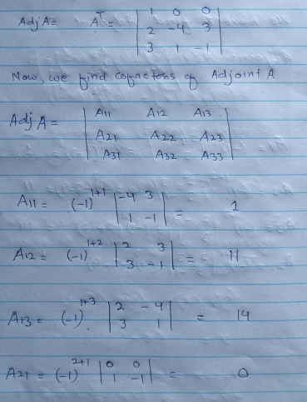

Part (4)

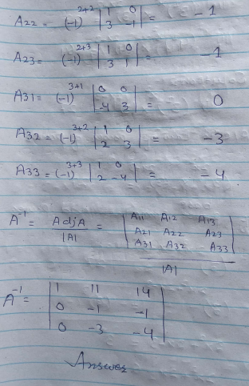

Task (2)



$${\left(x^{2}\right)}^{x^{2}}+{\left(x \right)}^{2x-3 }=27$$

A/C to Law of power of power

$${\left(3\right)}^{2x^{2}}+{\left(3\right)}^{2x-3 }=27$$

If base same then add power

$${\left(3\right)}^{2x^{2}+2x-3}=27$$

$$\left(2x^{2}+2x-3\right)=3$$

$$\left(2x^{2}+2x-6\right)=3$$

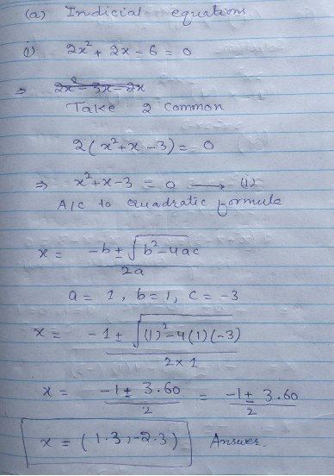

b).

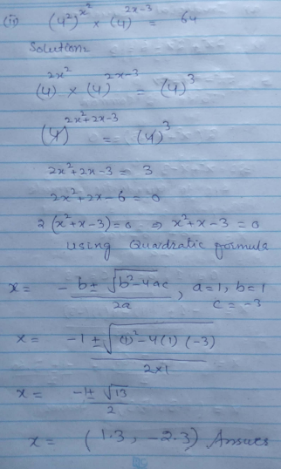

LO3

Task (1)

Let Probability of failure

p = 0.071 and Probability of success q = 0.929

By using binomial expansion, we get

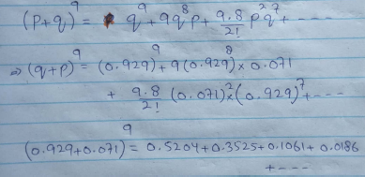

Probability of failure to meet specification up to three blocks

The three blocks **P = 0.0186** because Probability corresponds to 0,1,2,3

b).

Probability that less than four blocks =0.5204+ 0.3525+0.3525+0.1061+0.0188

**P= 0.9976**

Task (2)

**(a).**

**Histogram (January)**

|  |  |  |  |
| --- | --- | --- | --- |
| **Class Boundries** | **Width** | **Frequency** | **Proportional Height** |
| **0-5** | **5** | **27** | **5.4** |
| **5- 10** | **5** | **38** | **7.6** |
| **10-15** | **5** | **40** | **8** |
| **15-20** | **5** | **22** | **4.4** |
| **20-30** | **10** | **13** | **1.3** |
| **30-40** | **10** | **4** | **0.4** |

The histogram is shown as under of (January)

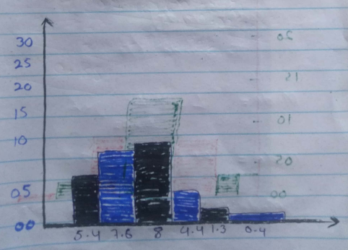

**Histogram (July)**

|  |  |  |  |
| --- | --- | --- | --- |
| **Class Boundaries** | **Width** | **Frequency** | **Proportional Height** |
| **0-5** | **5** | **22** | **4.4** |
| **5- 10** | **5** | **39** | **7.8** |
| **10-15** | **5** | **69** | **13.8** |
| **15-20** | **5** | **41** | **8.2** |
| **20-30** | **10** | **20** | **2** |
| **30-40** | **10** | **5** | **0.5** |

The histogram is shown as under of (January)

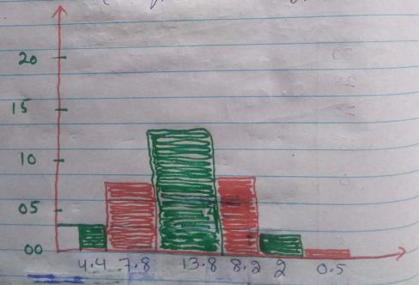

1. Frequency density and the mode

**Frequency density (January)**

Fd1 = Frequency / width = 27/5= 5.4

Fd2 = Frequency / width = 38/5= 7.6

Fd3 = Frequency / width = 40/5= 8

Fd4 = Frequency / width = 22/5= 4.4

Fd5 = Frequency / width = 13/10= 1.3

Fd6 = Frequency / width = 4/10= 0.4

**Frequency density (July)**

Fd1 = Frequency / width = 4.4

Fd2 = Frequency / width = 7.8

Fd3 = Frequency / width = 13.8

Fd4 = Frequency / width = 8.2

Fd5 = Frequency / width = 2

Fd6 = Frequency / width = 0.5

**b).**

**the mode January**

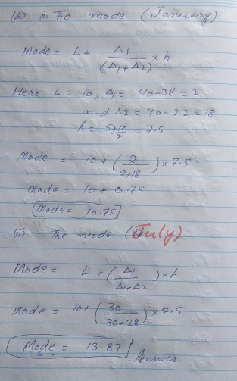

**Cumulate frequency curve and find interquartile range**

**For January (distribution)**

|  |  |  |
| --- | --- | --- |
| **Class Interval** | **Frequency** | **Cumulative frequency** |
| **0-5** | **27** | **27** |
| **5- 10** | **38** | **65** |
| **10-15** | **40** | **105** |
| **15-20** | **22** | **127** |
| **20-30** | **13** | **140** |
| **30-40** | **4** | **144** |

**Cumulate frequency curve can plotted from above table as (5,27), (10,65), (15,105), (20, 127), (30,140), (40,144)**

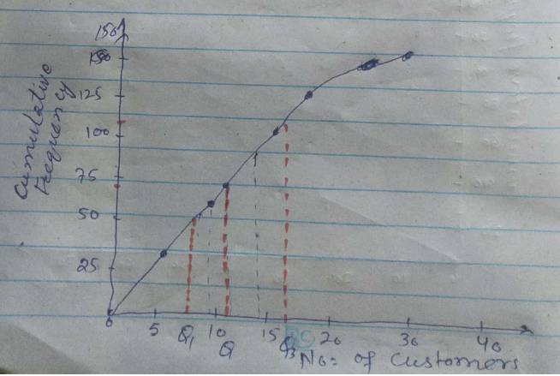

**There are 144 values, so median will be 144+1/2 =72.5**

Interquartile = q3 –q1

Interquartile = 116 – 8.5

Interquartile Range = 8

**Cumulate frequency curve and median interquartile range**

**For July (distribution)**

|  |  |  |
| --- | --- | --- |
| **Class Interval** | **Frequency** | **Cumulative frequency** |
| **0-5** | **22** | **22** |
| **5- 10** | **39** | **61** |
| **10-15** | **69** | **130** |
| **15-20** | **41** | **171** |
| **20-30** | **20** | **191** |
| **30-40** | **5** | **196** |

**Cumulate frequency curve can plotted from above table as (5,22), (10,61), (15,130), (20, 171), (30,191), (40,196)**

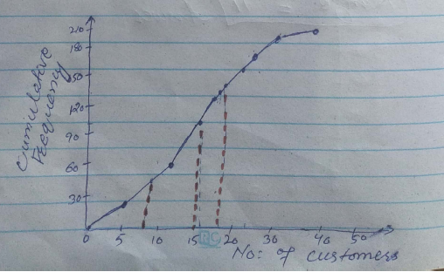

**There are 196 values, so median will be 196+1/2 = 98.5**

Interquartile = q3 –q1

Interquartile = 19 – 8

Range = 11

**c).**

For the January Distribution first draw frequency distribution table

|  |  |  |  |
| --- | --- | --- | --- |
| Class interval | Frequency | Mid-point | xifi |
| 0-5 | 27 | 2.5 | 67.5 |
| 5-10 | 38 | 7.5 | 285 |
| 10-15 | 40 | 12.5 | 500 |
| 15-20 | 22 | 17.5 | 385 |
| 20-30 | 13 | 25 | 325 |
| 30-40 | 4 | 35 | 140 |
|  | Sum =144 |  | Sum= 1702.5 |

1. The mean

$$\overline{x}=\frac{\sum{xifi}}{\sum{fi}}$$ = 1702.5/ 144

$\overline{x}$ = 11.82 Answer

(2)

The range

Range upper class boundary of the richest interval – lower class of the lowest interval

Range = 40-0 = 40

**(3)**

The standard derivation CB = class boundary

|  |  |  |  |  |
| --- | --- | --- | --- | --- |
| Class Boundary | Fi | xi | (Xi-u)^2 * fi | u |
| 0-5 | 27 | 2.5 | 2345.28 | 11.82 |
| 5-10 | 38 | 7.5 | 709.17 | 11.82 |
| 10-15 | 40 | 12.5 | 18.49 | 11.82 |
| 15-20 | 22 | 17.5 | 709.77 | 11.82 |
| 20-30 | 13 | 25 | 2258.26 | 11.82 |
| 30-40 | 4 | 35 | 2149.24 | 11.82 |
| sum | 144 |  | 8190.21 |  |

$$S.D=ρ= \sqrt{\sum{\frac{{\left(xi-u\right)}^{2}fi}{n}}} \\ S.D=ρ= \sqrt{\frac{8190.21}{144}}$$

$$5.0=ρ= 7.54$$

**c).**

Mean Range and Standard derivation

For July Distribution

CI= Class Interval

|  |  |  |  |
| --- | --- | --- | --- |
| Class interval | Frequency | Mid-point | xifi |
| 0-5 | 27 | 2.5 | 55 |
| 5-10 | 38 | 7.5 | 292.5 |
| 10-15 | 40 | 12.5 | 862.5 |
| 15-20 | 22 | 17.5 | 717.5 |
| 20-30 | 13 | 25 | 500 |
| 30-40 | 4 | 35 | 175 |
| sum | 196 |  | 2602.5 |

1. The mean

$$\overline{x}=\frac{\sum{xifi}}{\sum{fi}}$$ = 2602.5 / 196

$\overline{x}$ = 13.27 Answer

(2)

The range

Range upper class boundary of the richest interval – lower class of the lowest interval

Range = 40-0 = 40

(3)

The standard derivation CB = class boundary

|  |  |  |  |  |
| --- | --- | --- | --- | --- |
| Class Boundary | Fi | xi | (Xi-u)^2 * fi | u |
| 0-5 | 22 | 2.5 | 2551.8 | 13.27 |
| 5-10 | 39 | 7.5 | 1298.4 | 13.27 |
| 10-15 | 69 | 12.5 | 40.91 | 13.27 |
| 15-20 | 41 | 17.5 | 733.60 | 13.27 |
| 20-30 | 20 | 25 | 2751.8 | 13.27 |
| 30-40 | 5 | 35 | 2360.9 | 13.27 |
| sum | 196 |  | 9737.41 |  |

$$S.D=ρ= \sqrt{\sum{\frac{{\left(xi-u\right)}^{2}fi}{n}}} \\ S.D=ρ= \sqrt{\frac{9737.41}{196}}$$

$$5.D=ρ= 7.04$$

**Task 3**

Let force F=x and time Y

A table is produced as shown below

|  |  |  |  |  |
| --- | --- | --- | --- | --- |
| **x** | **y** | **X^2** | **xy** | **Y^2** |
| 11.4 | 0.56 | 129.96 | 6.384 | 0.3136 |
| 18.7 | 0.35 | 349.69 | 6.545 | 0.1225 |
| 11.7 | 0.55 | 136.98 | 6.545 | 0.3025 |
| 12.3 | 0.52 | 151.29 | 6.396 | 0.2704 |
| 14.7 | 0.43 | 216.09 | 6.321 | 0.1849 |
| 18.8 | 0.34 | 353.44 | 6.392 | 0.1156 |
| 19.6 | 0.31 | 384.16 | 6.076 | 0.961 |
| $\sum{X}$**= 107.2** | $\sum{Y}$**= 3.06** | $\sum{X^{2}}$**=1721.52** | $\sum{XY}$**=44.54** | $\sum{Y^{2}}$**= 1.4056** |

**Substituting in to**

$$\sum{Y=90N+91\sum{x^{2}} }$$

$$and \sum{XY=90∑x +91\sum{x^{2}} }$$

**Gives = 3.06 + 90*7 + 91 (107.2)-----(1)**

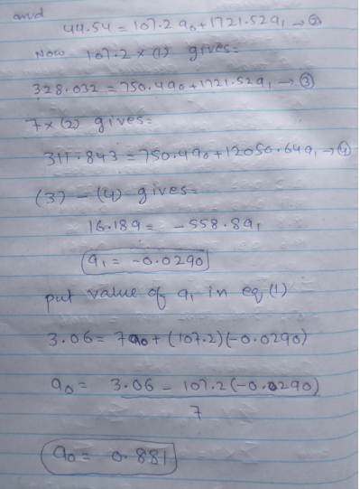

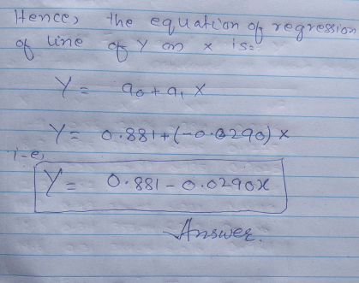

LO4

Task (1)

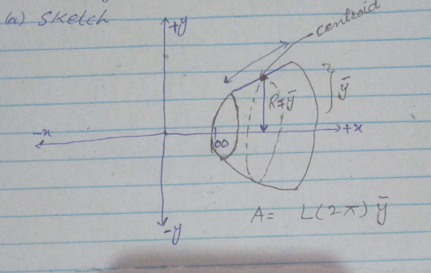

$$A=L\left(2π\right)\left(\frac{2R}{π}\right)$$

$$A=L\left(\frac{2πR}{2}\right)(2π)\left(\frac{2R}{π}\right)$$

$$A=4πR^{2} , R=\frac{A}{4π}$$

$$A=4\left(3.142\right){\left(100\right)}^{2}$$

$$A=125,680 mm^{2}$$

Task 3

First we eill find yc coordinate of the centroid ,yc = Mx/A

Mx is the First movement of area

$$Mx= \int_{-x+2}^{2x-1}{}\int_{-x+2}^{2x-1}{ydydx}$$

First integrate with y, we get

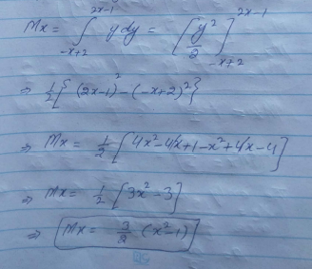

**Now integrate with x, we get**

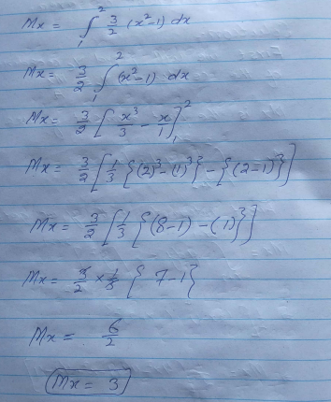

**The only remaining thing is the area of triangle**

$$A=\frac{bh}{2}$$

$$yc=\frac{Mx}{A}=\frac{3}{\frac{bh}{2}}$$

$$yc=\frac{6}{bh}$$

$$A=\frac{bh}{2}$$

Now we find the coordinate for centroid

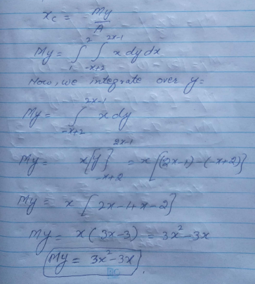

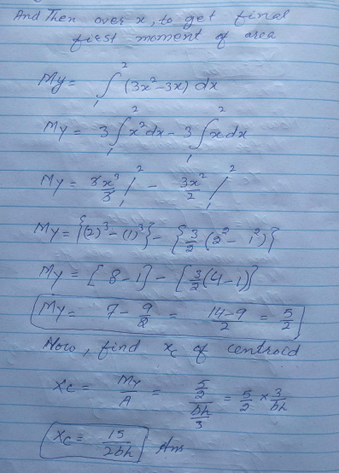

Now the calculate the second moment of area

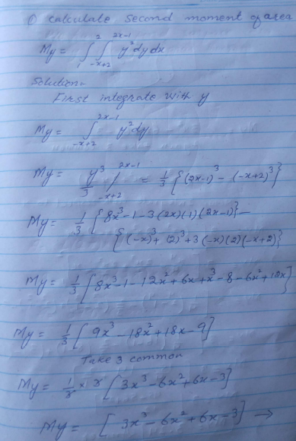

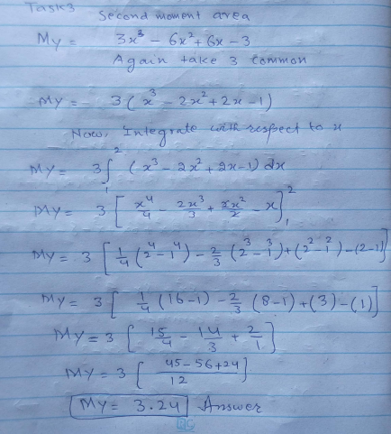

**Task 4**

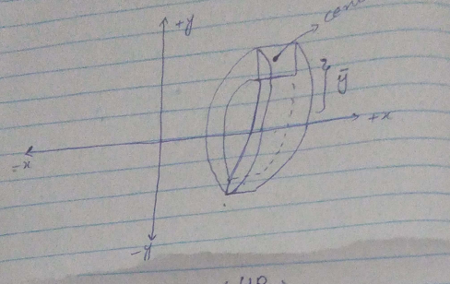

$$V=A\left(2π\right)\left(\frac{4R}{3π}\right)$$

$$V=\frac{1}{2}\left(πR^{2}\right)(2π)\left(\frac{4R}{3π}\right)$$

$$V=4π\frac{R^{3}}{3}=\frac{4}{3}π R^{3} , R=200$$

$$V=\frac{4}{3}\left(3.142\right){\left(200\right)}^{3}$$

$$V=33514,66m^{3}$$