ENGINEERING SCIENCE

Engineering Science

[Name of Student]

[Name of Institute]

**Task 1**

Part (a)

That report contain procedure of the Computational and Qualitative for the understanding of the electrical and mechanical concepts. So in this report through computer simulation the prototype model is used.so in the some cases the method of analytical are lengthy as it is too completed and in this way we use computational model. For the design, analysis, model and simulation is so efficient due to engineering context and that can solve the multifaceted problems. Computer software is used for efficient solution af the engineering problem through the sequence of the steps. And also provide the solution procedure. Qualitative is the primary analysis data which can determine by engineering but it can’t be computed

The qualitative word is measure the closely to the real value. These real value can represented the accuracy of the object.so explaining the result data of qualitative analysis can use as help in result by analysis of numerical and the computational method

**The S.I units, notations and Symbols**

SI is the international unit system that can used in the all the world. Metric system is used for the quantities of the measurement. This system can be accepted by internationally. This system used are in the Kelvin, amperes, meters, moles, seconds, , candela, temperature, kilograms for, current, length, mass, and time respectively (Nategh, 2013).

Prefixes are used to show large the units as well as in the smaller value. These are used for the exponentially large numbers and there are twenty two unit of drive for the basic kilogram-meter- second units.

**Prefix Notation**

The second name of the unit prefix matrix that can specific the unit of measurement to explain the fraction of the unit or the unit multiple. Internationally in its these prefixes are consider as the generic

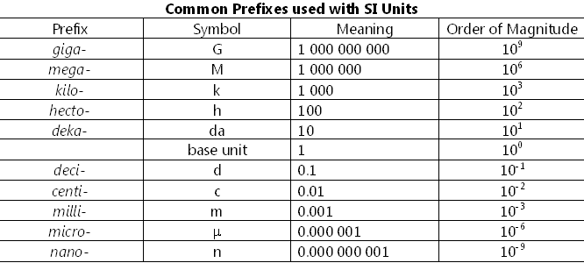

**Symbols**

In the symbols that can use to denote the seven units to identified the system.

For the temperature kelvin is used, for length measurement meter is used, for mass measurement kg is used , for current measurement ampere is , for luminous intensity measurement candela is used, and for material quantity mole is used.

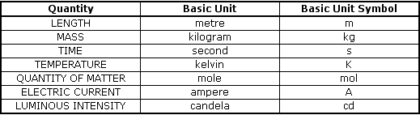

**Derived unit**

Derived unit are derived through the si system units for example newton is used as calculate to drive the power unit.

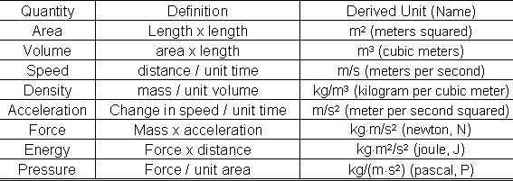

Part (b)

For the correct value display the representation of graphical is used to comparison of the quantities, decreases to projections as a bars of pie slices, etc ..

Data consistency can br accomplished by the graph numerical that can show along the qualitative structure and for the estimating micro excel is used for the graphical representation of results (Islam, Et.al, 2018).

The positioning calculation of the grid cells, data collection, web access, conditional formatting and Microsoft excel facilities data measurements.

*Party (c)*

For complete the computing and qualitative analysis in the process for formulation of the report with scientific approaches. Authentication empirical and a authentication proof is provided by empirical proof and authentic verification can give for studies of the science.

Obtain knowledge for this obtain from observation and logic. For the explanation of statistical equation computational diagram is used for easier elaboration (Islam, Et.al, 2018).

Scientific tools are used to dive a authentic suggestion of hypotheses. The representation of the data helped properly to explain the reading & values.

Part (d)

Graphical method are represent the optimum performance in data analysis for interpretation of data. Graph is the essential method for interpretation and estimation of knowledge. It can explain the data feature to accessible the distinctive manner. So through the help of the successful static & complex equation and mathematical equation can be solved.

For data histogram, box chart, visualisation and the data plotting are used for graphical data processing. For the several factor comparing average, dataset, & outliers, the graphic of the data offer the information about distribution for help. So in graphical data qualitative analysis is also used.

# Task2

Part (a)

Metals are strong electrical and heat conductors. This are malleable matter, and in thin sheets they can alter quickly. Wire is ductile in design, allowing the wire to mould metal. The energy & electronegativity level of ionisation is strong in non-metal. As subordinate conductors of electricity & heat, non-metals are considered (Ueberhuber, 2012). The ductility is absent in non-metal and has malleability with easily accumulating metallic lustre electrons on non-metal. Degradation is broken into two chemical groups and physical products. The distorting force employed on the body is elastic hysteresis. In the resulting strain that is used, it is not able to steadily adjust with stress & this stress is lagging behind in addition. The strain that lags is elastic hysteresis. It means changes in the characteristics of the circuit switch, typically amplifier circuits. In comparator amplifiers, elastic hysteresis is primarily used which takes into account the voltage in 2 inputs & defines output as an outcome current (Redmer, 2010). Single path magnetised magnetic hysteresis. In the event where the magnetic field is eradicated, it never reaches zero magnetization. The magnetic field never hits the point of initiative, and stays triggered

Part (c)

Aim of the experiment to check metal and non-metal properties during using practical data

During perform the materials burner, sand paper, cell, zinc, sulpher, hydrogen, copper foil, magnetic ribbon, touch cell and lamp. Now this experiment check the conductivity and check the property of metal. So before connect note the color and malleability and sand paper is used to clean the material before looking them. Than set the circuit of lamp to cell with push button in the series to connect then test the conductivity of the each material. After that the result metal is shines after the accurate cleaned but the nonmetal is dull in show. So in this way metals conduct heat and the well electricity. (revision.co.zw)

**Task (3)**

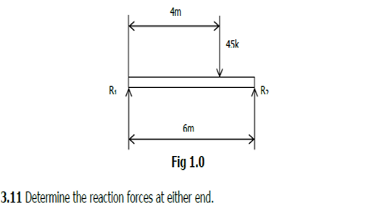

**Answer**

As per equilibrium equation sum of all torques at a given point is zero i.e.

$$\sum{τ}=0$$

where $τ=r*F$

Taking R1 as the pivot point all the clockwise torques are taken as positive and anti-clockwise torques as negative, implies

Taking R2 as the pivot point all the clockwise torques are taken as positive and anti-clockwise torques as negative, implies



$$R_{1}*6-45k*2=0$$

$$R_{2}=15kN$$

**Answer**

The weight of the beam is = $W_{g}=mg=39*9.81=0.382kN$

Considering the weight is at the middle with downwards force as shown below.

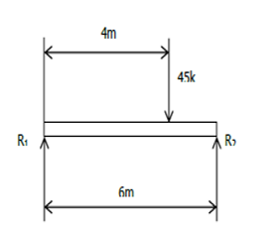

**Weight at 3m**

As per equilibrium equation sum of all torques at a given point is zero i.e.

$$\sum{τ}=0$$

where $τ=r*F$

Taking R1 as the pivot point all the clockwise torques are taken as positive and anti-clockwise torques as negative, implies

Taking R2 as the pivot point all the clockwise torques are taken as positive and anti-clockwise torques as negative, implies



$$R_{1}*6-45k*2-0.382k*3=0$$

$$R_{2}=15.191kN$$

The ability of an object to float is termed as ‘Buoyancy’.

Buoyancy is governed by to important physical parameters which are weight of the object and the volume of the object.

Keeping in view the floating condition of the object it is either termed as positive buoyancy or negative buoyancy.

Positive buoyancy is when object floats on water and negative buoyancy is when it sinks.

The examples of the buoyancy is the hot air balloons and the submarine

In the hot air balloons, the air inside the balloon is heated up which make the air inside is less dense then the outside cold air. If the air inside the hot balloon is not heated up the air inside become dense and the balloon loses altitude.

Similarly, the submarine is floats and dive on the principle of buoyancy, keeping in view the positive and negative buoyancy. In the submarine, there is a large tank which either take or rejects water. When the submarine takes the water inside the tank is creates a negative buoyancy by increasing the weight of the ship from the buoyant force which helps in sinking and when the water is rejected the weight decrease and the buoyant force is greater than the weight the submarine rises up the water.



**Answer**

The increase in temperature cause the molecule of the material to attain the highly mobilizing state and transfer heat on cooling or letting the material to cool at room temperature, will result in slight increase in dimension of the material. The practice example are the railway track which expand in summer season and contract in winter.

Part



**Answer**

As per the d’Alembert’s Principle



$$F-ma=0$$

$$F=ma$$

$$a=F/m=\frac{150}{60}=2.5{ms}^{-2}$$

**Answer**

Performance of the system is governed by the thermal efficiency of the system. With the increase in thermal efficiency the heat transfer will be maximum and depending on the system it will be either performance increase or decreasing. For example, if we are working on the boiler the thermal efficiency high means high temperature is being achieved then the performance of the system is high.

**Task 4.0**

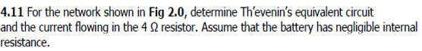

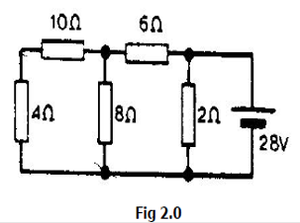

**Answer**

**Background**

As per Thevenin’s equivalent circuit the whole circuit could be transformed to a voltage source and an equivalent resistance connected to a load as shown below

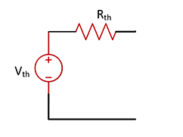

In the circuit shown above

$$V_{th}= V_{oc}; Open Circuit Voltage$$

$$R_{th}=Equivalent Resistance as seen from source$$

In determining both the factors the load is not considered and while determining the Rth value the voltage source is replaced with a short circuit and the current source is replaced with an open circuit.

**To Find:**

1. Thevenin Equivalent Circuit
2. Current through 4Ω resistance.

**Solution:**



A

Load Side Circuit

For finding the Vth we have to consider the resistance at load end (4Ω) is out of picture and the voltage across 4Ω resistance is equal to voltage across 8Ω resistance. So after assuming the direction of currents and applying KCL for node A the equation become

Current entering node A = Current exiting node A

$$\frac{V_{source}-V_{A}}{R_{6Ω}}=\frac{V_{A}-0}{R_{8Ω}}$$

$$\frac{28-V_{oc}}{6}=\frac{V_{oc}}{8}$$

$$\left(28-V_{oc}\right)*8-6*V_{oc}=0$$

Which implies

$$V_{oc}=16V$$

Now considering the voltage source as short circuit and looking from the load side



The circuit will look like the 2Ω resistance is being bypassed. Which is in series with 6Ω resistance and this is in parallel with 8Ω resistance and further the circuit is in series with 10Ω resistance.

The value becomes

$$R_{th}=10+(6||8)$$

$$R_{th}=10+(\frac{6*8}{6+8})$$

$$R_{th}=13.4Ω$$

The Thevenin equivalent circuit becomes

13.4Ω

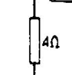

16V

The current through resistance 4Ω will be found through ohms law.



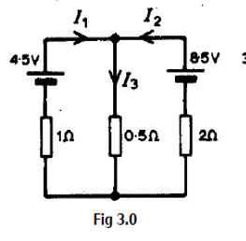

**Answer**

Considering one source at a time and the other source as short circuit.

Considering 8.5V source as short circuit.

The Current I1 becomes the current flowing through parallel combination of 2Ω and 0.5Ω which is in series with 1Ω resistance

So

$$I_{1}=\frac{4.5}{1+(2||0.5)}=3.2A$$

Similarly solving for I2

$$I_{2}=\frac{8.5}{2+(1||0.5)}=3.64A$$

In the end the current I3 is the sum of current I1 and I2, so

$$I_{3}=I_{1}+I_{2}=6.8A$$

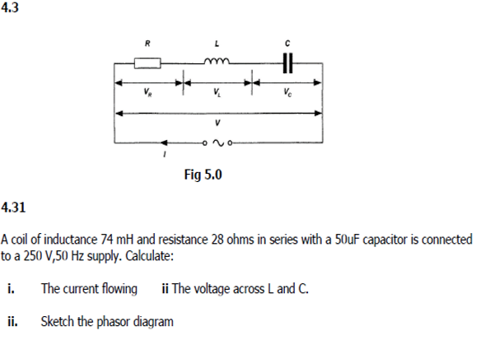

**Answer**

Based on the available data first we find the impedance of the inductor and capacitor

$$X_{L}=ωL=2πfL=2*3.14*50*74m=23.236Ω……………………. for inductor$$

$$X_{C}=\frac{1}{ωC}=1/{2πfC}=\frac{1}{2*3.14*50*50*{10}^{-6}}=63.69Ω……………….for capacitor$$

The impedance of the whole RLC series circuit is

$$Z=\sqrt{R^{2}+{(X_{L}-X_{C})}^{2}}$$

$$Z=\sqrt{{28}^{2}+{(23.236-63.69)}^{2}}$$

$$Z=49.19Ω$$

Now the current from the circuit is

$$I=\frac{V_{source}}{Z}=\frac{250}{49.19}=5.08A$$

Now the current is found the voltage across each of the component could be measured

$$V_{L}=I*X_{L}=5.08*23.236=118V$$

$$V_{C}=I*X_{C}=5.08*63.69=323.54V$$

For phasor diagram angle is

$$tanΦ=\frac{X_{L}-X_{C}}{R}=>Φ=-{55}^{O}$$

-ive sign indicates a capacitive circuit. Which means current of the circuit leads the voltage by 55O.

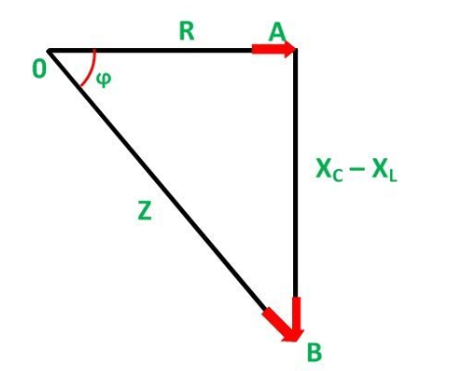

28Ω

40.45Ω

49.19Ω

55o

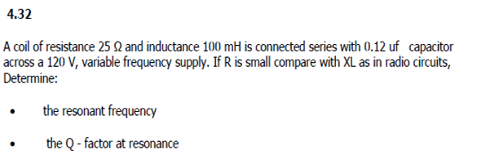

**Answer**

The resonant frequency is determined when the impedances of inductor and capacitor becomes equal.

$$X_{L}=X_{C}$$

$$2πfL=\frac{1}{2πfC}$$

After solving for resonant frequency fo we get

$$f_{o}=\frac{1}{2π\sqrt{LC}}=\frac{1}{2*3.14*\sqrt{100*{10}^{-3}*0.12*{10}^{-6}}}=1.452kHz$$

The quality Q-factor of the RLC series circuit is given as

$$Q=\frac{1}{R}\sqrt{\frac{L}{C}}=\frac{1}{25}\sqrt{\frac{100*{10}^{-3}}{0.12*{10}^{-6}}}=36.5$$

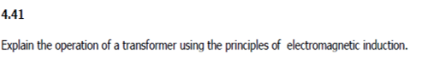

Transformers work on the farady’s law of electromagnetic induction which states that current will be induced in a conductor when placed in a change in magnetic field.



The above equation in accordance with transformer states that when a supply V having a frequency is connected to the primary side of the transformer, the primary coil/winding become energized. The magnetic field is created in the primary coil as

$$V=L\frac{di(t)}{dt}$$

The current flowing through the primary coil is changing with the time which induces flux and the core gets magnetized and the secondary coil gets induced by the magnetic fields coming from the core of the transformer.

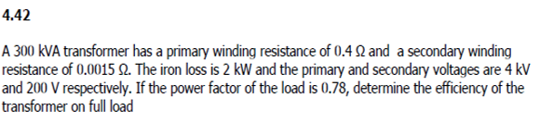

**Answer**

Power of Transformer = S = 300kVA

Primary voltage of transformer = $V_{1}=4kV$

Secondary voltage of transformer = $V_{2}=200V$

Transformer Ratio = $\frac{V_{1}}{V_{2}}=\frac{4kV}{200V}=20$

So the primary current of the transformer is = $I_{1}= \frac{S}{\sqrt{3}*V_{1}}= \frac{300kVA}{1.732*4kV}=43.3A$

And the secondary current of the transformer is = $I_{2}= \frac{S}{\sqrt{3}*V_{2}}= \frac{300kVA}{1.732*200V}=866A$

The efficiency of the transformer is = $η=\frac{P_{output}}{P_{input}}*100\%=\left(\frac{P_{input}-P_{losses}}{P_{input}}\right)*100\%$

$η=\left(1-\frac{P_{losses}}{P_{input}}\right)*100\%$-------------------------------(i)

Losses of transformer = $P_{losses}=P_{iron losses }+ P_{copper losses primary }+P_{iron losses secondary }$ (ii)

$$P_{iron losses }=2kW$$

$$P_{copper losses primary}=I_{1}^{2}*R_{primary}={43.3}^{2}*0.4=749.9W=0.745kW$$

$$P_{copper losses secondary}=I_{2}^{2}*R_{secondary}={866}^{2}*0.0015=1124.9W=1.125kW$$

Then equation (ii) becomes

Losses of transformer = $P_{losses}=P_{iron losses }+ P_{copper losses primary }+P_{iron losses secondary }$

$$P_{losses}=2kW+ 0.745kW+1.125kW=3.87kW$$

The transformer is operated at full load with 0.78 power factor than the load power will be

$$P_{input}=S*PF=300kVA*0.78=234kW$$

Then equation (i) becomes

$$η=\left(1-\frac{P_{losses}}{P_{input}}\right)*100\%$$

$$η=\left(1-\frac{3.87kW}{234kW}\right)*100\%=98.3\%$$

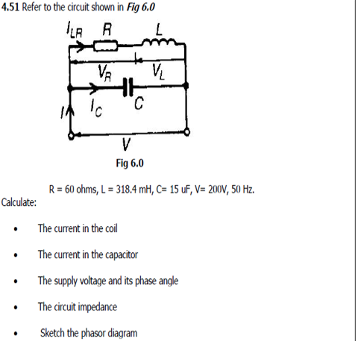

**Answer**

First we will find the impendences of the circuit

$$Z_{L}=jωL=j2πfL=2*3.14*50*318.4m=j99.976=\sim j100Ω$$

$$Z_{C}=1/{jωC}=1/{j2πfC}=1/{j(2*3.14*50*15μ)}=-j212.314Ω$$

The impedance of RL series circuit is

o

The current through the coil L is

$$I_{coil}=\frac{V}{Z_{RL}}=\frac{200V}{116.6<59ᵒ}=1.715<-59ᵒA$$

The current in the capacitor C is

$$I_{capacitor}=\frac{V}{Z_{C}}=\frac{200V}{-j212.314}=0.942<90ᵒA$$

In the circuit the supply voltage is considered at 0ᵒ

$V_{supply}=200<0ᵒ$ V

The equivalent impedance is

o

The current through the capacitor is

$$I_{total}=I_{capacitor}-I_{coil}=0.942<90ᵒ+ 1.715<-59ᵒ=1.02<-30.87ᵒ A$$

Approximate phaser diagram is

Icap= $0.942<90ᵒA$

V=200V<0

I total= $1.02<-30.87ᵒA$

Icoil= $1.715<-59ᵒA$

**References**

* <https://www.translatorscafe.com/unit-converter/en-US/calculator/series-rlc-impedance/>
* <https://www.engineeringclicks.com/buoyancy/>
* <https://www.quora.com/What-are-the-applications-of-buoyancy>
* Effect of temperature changes on the dimensional stability of elastomeric impression materials Published On: 26-02-2014
* Chen, W.K., 2004. The electrical engineering handbook. Elsevier.
* Ghodselahi, T., Vesaghi, M.A., Shafiekhani, A., Ahmadi, M., Panahandeh, M. and Saani, M.H., 2010. Metal–nonmetal transition in the copper–carbon nanocomposite films. Physica B: Condensed Matter, 405(18), pp.3949-3951.
* Islam, M.T. and Huda, N., 2018. Reverse logistics and closed-loop supply chain of Waste Electrical and Electronic Equipment (WEEE)/E-waste: A comprehensive literature review. Resources, Conservation and Recycling, 137, pp.48-75.
* Nategh, S., 2013. Thermal analysis and management of high-performance electrical machines (Doctoral dissertation, KTH Royal Institute of Technology).
* Powell, N.J., Peaker, A.R., Truscott, W.S., Hicks, P.J. and Canavan, B., 2007, September. Seeding Enquiry-Based Learning in Electrical and Electronic Engineering: Case Study 1–Optoelectronics. In International Conference on Engineering Education, ICEE Coimbra.
* Redmer, R. ed., 2010. Metal-to-nonmetal Transitions (Vol. 132). Berlin: Springer.
* Ueberhuber, C.W., 2012. Numerical computation 1: methods, software, and analysis. Springer Science & Business Media.